OMAN AVIATION GROUP
Autonomous Disruption Recovery
A walkthrough
What it solves, what it does, and where the AI is
Written for | the General Manager, and for anyone who has to explain this system without its author in the room
Status | Demonstration build. Not connected to any live system.
Data | Synthetic throughout. No real passenger, booking or flight.
Model | Claude Opus 5 by default; Sonnet 5 and Haiku 4.5 selectable at runtime
Solver | Google OR-Tools CP-SAT — cpsat, version 0.1.0. It, not the model, assigns the seats.
Write access | None. The agent proposes the entries; controllers make them.
Revision | 3d4b082, measured 3 September 2026
Figures measured | 3 September 2026

Every number in this document was measured on the date given beside it, not estimated. Every screenshot was captured from the running product. Where something is a stand-in rather than the real thing, it says so in the body of the text and not in a footnote.

Contents

READ THIS FIRST — THE PAGE NUMBERS ARE NOT FILLED IN YET
Word builds this list on demand rather than storing it. Press Ctrl+A then F9, and if it asks, choose Update entire table. The headings and page numbers appear. Do the same after any edit that moves the text. Handing this over without doing it is the one way to give somebody a document with an empty contents page.

Section 5 is the one to read if you read only one. It walks the whole night in the order it happens, and every stage says in plain words what the system does, where the AI is, and what checks it.

1 Start here

The flow, in one line

THE WHOLE NIGHT
A flight is cancelled → the agent builds the picture and reads what passengers wrote → a solver assigns every seat → the agent explains who does badly and why → a duty manager signs what is theirs to sign → a controller types the entries → the agent reads the bookings back and says nothing has moved yet

The whole solution, in one paragraph
A flight is cancelled at 23:40 with 26 passengers on it and 24 seats available across the next three departures. Two people are not flying tonight, and deciding which two is not a clerical task: it is a judgement about a funeral, an infant, a wheelchair, a prepaid hotel and a group of eight who must stay together. Meanwhile passengers are texting a published number at midnight in two languages, and the hotel has replied to a room request in prose that contains four conditions and two deadlines. Autonomous Disruption Recovery does the reading and the arithmetic. It reads every message and works out what each person actually needs, turns the hotel's paragraph into firm numbers, and then hands the seat allocation to a constraint solver — not a language model — which places everybody it can inside hard limits on seats, infants and wheelchairs. Then it does the thing that matters most: before asking for anything, it explains who comes off worst and why. Every decision that spends money or reaches a passenger stops for a named person. It writes nothing into the airline's systems; it produces the exact entries a controller types, and afterwards reads the bookings back and reports that nothing has moved yet. What changes is that at 23:45 a duty manager has a defensible plan, the reasoning behind it, and a written list of who it treats badly.

The one rule

THE ONE RULE — AND THE SYSTEM ENFORCES IT, IT IS NOT ASPIRED TO
A solver decides who flies. The model reads, drafts and explains. A named person signs. Nothing is written to the airline's systems at all.
Three of those four are things you can point at in the source, not in a policy document:
1. The allocation is not a model call. The assign_seats tool calls Google OR-Tools CP-SAT in a separate package, with a fixed seed and published weights. Seats, infant capacity and wheelchair capacity are hard constraints — the solver cannot violate them, and given the same inputs it returns the same answer every time. It can also return no seat for this party, which is not an error but the correct answer when there are more passengers than seats.
2. Nothing the outside world would notice runs without a click. Every tool declares itself read or act. The three act tools — asking a duty manager for a decision, committing hotel spend, and messaging passengers — are never executed on the model's word. The run halts and its status becomes awaiting_approval until a person approves that exact call by its own id.
3. There is no write path to the passenger service system. The booking store reports can_write = False and its rebook() raises AccessDenied. More to the point, the agent is not offered a tool that writes: the whole toolbox contains no way to move a booking. What it produces instead is a checklist marked write_access: false.

Two qualifications, because somebody will find them. The control panel has a switch called Approve automatically, which exists so a run can be rehearsed without a person clicking a dozen times; while it is on, rule 2 does not apply. It is off by default and visible on the screen. And rule 3 is stronger in ADR than the equivalent rule in the baggage product: there, the agent attempts the write on every run and is refused, so you can read the refusal in its output. Here there is nothing to attempt, so the evidence is the absence of a tool rather than the presence of a refusal. Both are enforced; only one is visible on screen.

2 The problem it solves

23:40, and somebody is not flying
OV501 to Dubai is cancelled at 23:40. There are 26 passengers on it, spread across 8 bookings, and 24 seats across the next three departures — one at 06:00, one on a partner carrier at 08:30 that has to be paid for, and one at 14:20. Two people cannot be accommodated at all.
Deciding which two is the whole night. On that flight there is a man with a funeral in Kochi tomorrow afternoon, a parent travelling with an infant in arms, a 78-year-old couple of whom one uses a wheelchair and cannot manage stairs, a family of six with a prepaid Dubai hotel that lapses if they arrive late, a group of eight on a single booking who have to stay together, and two students who have said they do not mind waiting. Every one of those facts changes the answer, and none of them is a field in a reservation system: they are in messages people sent to a published number after midnight, three in English and two in Arabic.
Passengers on the cancelled flight | 26
Seats available across the next three departures | 24
Passengers who cannot be accommodated | 2
Messages waiting, in two languages | 5
Of those, written in Arabic | 2

Why this is structural, not a staffing problem
- The input is prose from frightened people, not a queue of tickets. Nobody fills in a form at midnight. What arrives is a daughter writing on behalf of her parents, a furious man threatening the regulator, and two Arabic messages about an infant and a prepaid hotel. Reading those and working out what each person actually needs is the first task, and it is a language task before it is an operational one.
- The allocation is a constrained optimisation, and a person doing it by hand will get it wrong. Three flights with different capacities, hard limits on how many infants and wheelchair passengers each can take, a group of eight that cannot be split, and a shortfall. There is a correct answer given a stated objective, and finding it is arithmetic — which means it should be solved, not guessed, and certainly not guessed by a language model.
- The decision about who is left behind is a policy question that was buried in a solver. Whether you fill every seat or protect the people who need help most is a choice the airline should be making deliberately. Until now it was two numbers inside an optimiser that nobody outside engineering had ever seen.

THE POINT OF THE WHOLE SYSTEM, IN ONE SENTENCE
This is three different problems wearing one coat — a reading problem, an arithmetic problem, and a judgement problem — and the entire design is about not confusing them: the model reads, the solver computes, and a person judges.

3 What it is

The definition
Autonomous Disruption Recovery is an agent for the moment after operations control has committed a cancellation. It builds the picture of who is affected, reads what those passengers have written and works out what each of them needs, turns a vendor's prose reply into firm numbers and deadlines, hands the seat allocation to a constraint solver, explains in writing who the resulting plan treats worst and why, asks a duty manager to sign the decisions that are theirs rather than its own, writes each passenger's message in their own language and picks the channel that will actually reach them, and produces the exact keystrokes a controller makes in the passenger service system — then reads the bookings back and reports how many have actually moved. It is 11 tools, four of which call a language model and one of which calls a solver.

What it is not
- It is not an optimiser with a chat interface. The solver is the smallest and fastest part of the system. Most of what the agent does is reading things people wrote and explaining what it has decided.
- It is not a language model doing arithmetic. No model assigns a seat, counts a room, or decides whether a party fits. Ask it to and it has no tool for it.
- It is not connected to anything. No passenger service system, no departure control, no hotel, no messaging gateway. It reads exports from disk and renders messages onto a phone-shaped screen.
- It does not decide who is left behind. It computes an allocation from weights a person chose, tells you who it treats worst, and asks for a signature on anything that would change it.
- It is not finished, and it is not governed yet. Getting in takes one shared password, handed out with the link; which of the four people you then are is not checked — although the roles it enforces and the signatures it records are real. The autonomy levels, circuit breakers and kill switch described in the project brief are not built. Section 10 is the list.

IF SOMEBODY ASKS 'WHY NOT LET THE AI DO THE ALLOCATION?'
This is the question the demonstration is built to answer, and the answer is not caution. It is that a solver is better at it: it is provably correct against its constraints, it returns the same answer every time, it can prove that no better arrangement exists, it can say that a party does not fit, and on this run it did the whole thing in 20 ms. The model call that explains the result took 38.86 s — roughly two thousand times longer. Use each for what it is good at.

4 How to think about it
Four layers, each with a discipline it is not allowed to break. If you remember the layers you can place any question somebody asks you.
Layer | What it is here | Its discipline
1. Records | Bookings, segments and inventory as CSV exports — the shape of a nightly drop — read through a port that only offers reads | Read, never write. The passenger service system is the record of truth and this holds a copy of it, never a second version.
2. Deterministic engines | The CP-SAT solver, the agent loop and its approval gate, the checklist builder, the read-back | Anything with a right answer is computed, never asked. Same inputs, same output, every time — the solver is seeded, and its weights are published in its own output.
3. The AI layer | Four tools that call a language model — triage, vendor extraction, explanation, drafting — plus the loop's own call that chooses what to do next | Every call is schema-bound and every one of them is about language or judgement, never about counting. None of them can move a passenger, spend money or send anything.
4. People | The duty manager who authorises, the controller who types, the passenger who receives | Each has exactly one thing they can do that nothing else can do, and the system stops and waits rather than working around it.

THE SHAPE OF THE WHOLE THING
Records → deterministic engines → the AI layer → people
Read it left to right and it is how a recovery plan is produced. Read it right to left and it is why the system is safe: a person acts before anything leaves layer 4, the model in layer 3 cannot reach layer 1 or move anybody, and the engine that decides who flies is in layer 2 where it can be tested.

Where each layer lives, if you want to look
Records | products/adr/domain/src/adr_domain/ports.py`, `exports.py
The solver | `products/adr/apps/optimizer/src/adr_optimizer/solver.py` — a separate package
Deterministic engines | loop.py`, `exports.py`, `demo_world.py
The AI layer | tools.py` (the four schemas), `llm.py
People | `apps/console` — 6 screens: the desk, what came in, the decisions, a passenger's phone, the control panel and the run history. `identity.py` is the roster and the permission table; roles are enforced in the API

5 The core flow, stage by stage
This is the section to read. It walks one cancellation from the messages arriving to a controller having something to type, in the order it happens. Every stage says what happens in plain words, lists what the product does there, shows the screen, and then says exactly where the AI is and what checks it.

HOW THESE SCREENSHOTS WERE MADE, AND WHAT THAT MEANS
Every image in this section was captured from the running product by a committed script, tools/capture-shots.mjs, which drives the console the way a person would: it presses Run recovery, clicks each approval, and reads the resulting screens. Nothing is drawn, staged or retouched.
Unlike the baggage walkthrough, this one is a single run. All twelve stages below come from run evt-ov501-20260903-174104 on 3 September 2026 — one continuous recovery of 333 seconds, 8 turns and 20 tool calls, with 5 approvals clicked by hand. The only exception is stage 12, which is the control panel and involves no model call at all.

Stage 1 — What actually arrived
Before pressing anything, look at the input, because everything downstream is impressive only in proportion to how unstructured this is. There is no queue of tickets and no form anybody filled in. There are 5 people texting a published number after midnight in two languages, and a hotel replying to a room request in ordinary email prose. No urgency field, no category, no reference number. The whole of what the airline knows about each of these evenings is a sentence somebody typed on a phone.
- Messages arrive on the channel the passenger used — WhatsApp or SMS — and are shown exactly as written.
- Arabic and English in the same list, each rendered in its own direction.
- A vendor email in the same place, because at midnight it is the same problem.
- Nothing is categorised, scored or prioritised on arrival.
Two of them are worth reading aloud before anything else happens, because between them they make the case for the entire system. Both are reproduced here as they arrived:
This is Mrs Fernandes daughter writing on behalf of my parents. My father uses a wheelchair and cannot do stairs at all. They are both 78. Please do not put them in a hotel without a lift. Also they do not have a smartphone so please call this number, do not send links.
message in-04, by SMS — the politest message on the page, and it never uses the word urgent
this is unacceptable. i have a funeral in kochi tomorrow afternoon and your staff just said wait. i need to be on the first flight
message in-01, by WhatsApp — the angriest, and it threatens the regulator
Ask the room which one is more urgent before running anything, and let them answer. The result arrives in stage 3 and it is not what most people expect.
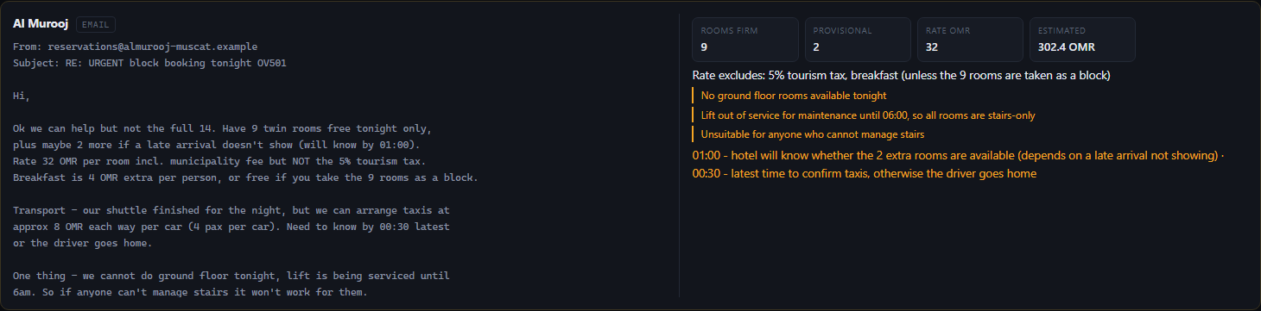
The hotel's reply, as it sits on the incoming screen. Seven hundred characters of prose containing a room count, a conditional room count, a rate that excludes a tax, a conditional breakfast, a taxi price, two separate deadlines, and — in the last sentence, almost as an afterthought — the fact that the lift is out of service.

ONE THING THIS SCREENSHOT CANNOT SHOW YOU
The /incoming rows carry their triage labels for as long as a run record exists, so the only way to photograph this screen with the right-hand column genuinely empty would be to delete the run this entire document is built from. Rather than caption a labelled row as raw input, the messages above are quoted from the data and the labelled rows appear in stage 3, where the labels are the point. Before any run has happened the right-hand side of every row is empty; you can see that for yourself by starting the product without pressing Run recovery.

NO AI IN THIS STAGE — AND WHAT MAKES THAT DELIBERATE
This screen is only a renderer. It is in the walkthrough because the input is the argument: a reader who skips it will assume the system was handed a tidy queue, and will then find the rest of the document unremarkable.

SAY IT IN ONE LINE
This is the input — not a form, not a queue, not a ticketing system: five people texting a public number at midnight in two languages, and a hotel replying in prose.

Stage 2 — The picture, and the shortfall
The desk shows what operations control has committed and what it means for people. The number to look at is the amber one: there are more passengers than seats.
- 26 passengers across 8 bookings on the cancelled flight.
- 24 seats across 3 onward options, one of them on a partner carrier and chargeable.
- A shortfall of 2, shown as its own figure rather than left to be worked out.
- Each party with its size and its special service requirements — wheelchair, infant in arms, meet-and-assist.
- Messages waiting, counted.
The three numbers that define the night. The amber '2 short' is the whole problem: somebody is not flying, and the rest of the system exists to decide who and to say so out loud.
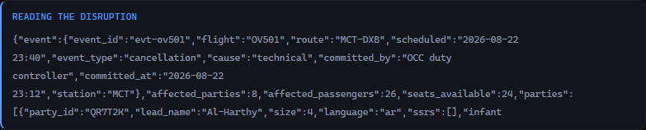
The first thing the agent does: read the disruption. Note what it is handed — a flight, a set of bookings, a set of onward options and their capacities. Every number here was computed before the run started; nothing in this card is a judgement.
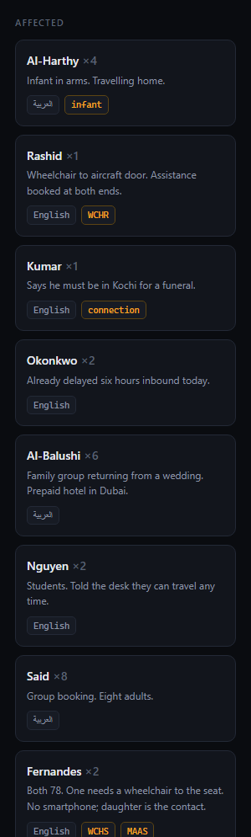
The parties, with the facts that will turn out to matter — sizes, wheelchair and infant flags. Note that none of these fields says anything about a funeral or a prepaid hotel; those are in the messages.

NO AI IN THIS STAGE — AND WHAT MAKES THAT DELIBERATE
Counting passengers and seats is arithmetic, so it is code, and the control panel measures the tool that builds this picture at under 1 millisecond. Worth noticing because it sets up the honest version of what follows: the agent begins by being told the numbers, not by working them out.

SAY IT IN ONE LINE
26 passengers, 24 seats, 2 short — somebody is not flying tonight, and which party and why is the whole evening.

Stage 3 — It reads what people wrote
The first model call. Every inbound message is read and turned into four things: what the person is asking for, how urgent it actually is, what language to answer in, and a flag for whoever is going to act on it. This is where the demonstration usually changes somebody's mind, because of what it does with the two messages from stage 1.
- One pass over all messages, so relative urgency is judged against the others rather than in isolation.
- Urgency from a fixed list: now, soon, or routine.
- The language detected and recorded, so the reply comes back in it.
- A free-text operational flag — the sentence a human would write on the top of the file.
- Explicit instruction in the call itself that anger is not urgency.
Five messages, read and labelled. Look at the urgency column against the tone of the messages in stage 1.
The clearest way to show it is the screen from stage 1, where each label sits beside the message it was derived from.
An Arabic message about an infant, read and labelled — the language detected, the need identified as care rather than rebooking, and a flag saying the reply must come back in Arabic.
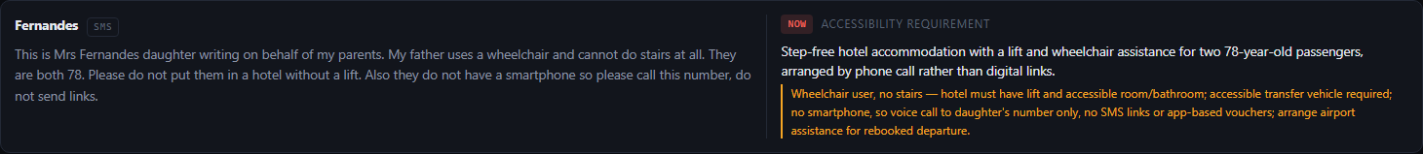
The politest message on the page with what the triage made of it: ACCESSIBILITY REQUIREMENT, urgency NOW, and an operational flag naming the lift, the accessible transfer and the fact that there is no smartphone. The original text is still on the left, so the reading can be checked against the words that produced it.
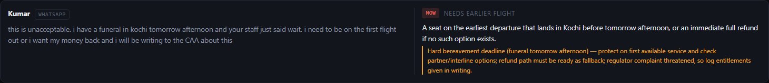
And the angriest, also NOW — but for a stated reason, a funeral with a fixed deadline, rather than because of how it was written.
What it concluded about the politest message on the page:
accessibility_requirement · urgency: now — “Step-free hotel accommodation with a lift and wheelchair assistance for two 78-year-old passengers, arranged by phone call rather than digital links.” Operational flag: “Wheelchair user, no stairs — hotel must have lift and accessible room/bathroom; accessible transfer vehicle required; no smartphone, so voice call to daughter's number only.”
triage_messages, message in-04, run of 3 September 2026
It is worth being precise about what this run showed, because the tempting version is slightly wrong. It is not that the angry message was downgraded: the man threatening the regulator was also rated urgency now, and correctly, because he has a funeral in Kochi tomorrow afternoon and a real entitlement behind the threat. What the reading actually shows is that tone carried no information at all. Of the five, three came back now, one soon and one routine — and the ordering has nothing to do with how loudly anybody wrote. The apology and the threat landed in the same band, and the message that sounded most relaxed was the only one deprioritised.
Two things came out of that single reading that change what happens later. The lift requirement collides with the hotel's email in stage 4 and produces a refusal in stage 7. And 'no smartphone' becomes the reason the message in stage 9 is delivered as a telephone call rather than a text — a channel decision nothing in the code makes.
And about the two students who said they did not mind:
accepts_any · urgency: routine — “Flexible party — can be used to free earlier seats for deadline-critical passengers; issue meal vouchers.”
triage_messages, message in-03, run of 3 September 2026
Remember that line. It is correct, it is what any competent controller would write, and it is the reason those two people end the night without a seat. Stage 6 is where the system says so.

WHERE THE AI IS — AND WHAT CHECKS IT
The model call: triage_messages reads all five at once. Measured 16.99 s for the single call on 3 September 2026.
What checks it. Urgency is a closed list of three values, so it cannot hedge with a paragraph. The original message stays on screen beside the label on the /incoming screen, so a person can disagree in a second — and the triage decides nothing on its own: it is an input to a solver run and to a plan a duty manager signs. If the triage is wrong, the wrongness is visible before it costs anybody a seat.

SAY IT IN ONE LINE
It read five messages and rated the politest one on the page as urgently as the angriest one — because the daughter who apologised was the one with a wheelchair user who cannot manage stairs, and tone told you nothing about that.

Stage 4 — It reads the hotel's reply
The second model call, and the one that is easiest to underestimate. The hotel's email from stage 1 is a paragraph a tired person wrote at midnight. It becomes a set of firm numbers, a list of what the rate does and does not include, two deadlines with times on them, and a list of what is still unresolved.
- Firm rooms separated from provisional ones, because the difference matters and the email blurs it.
- What the quoted rate excludes, extracted as its own field.
- Deadlines pulled out with their times and what expires at each.
- Accessibility problems as a separate list.
- An explicit list of what the reply does not settle, so nobody assumes it did.
Seven hundred characters of prose turned into fields. The three lines to look for: the tourism tax the quoted rate excludes, the two deadlines, and the lift.
What it pulled out, verbatim:
Rooms firm | 9, plus 2 provisional — confirmed only at 01:00
Rate excludes | the 5% tourism tax; breakfast, unless the nine rooms are taken as a block
Deadline | 00:30 — taxis must be confirmed or the driver goes home
Deadline | 01:00 — whether the two extra rooms exist
Accessibility | no ground-floor rooms, and the lift is out of service until 06:00 — every room is stairs-only
Still unresolved | only 9 of the 14 rooms requested are firm; the remaining passengers must be accommodated elsewhere

The last row is worth pausing on. Nobody asked it to check whether the offer covered the requirement. It compared the rooms offered against the rooms requested and reported the gap as an open item.

WHERE THE AI IS — AND WHAT CHECKS IT
The model call: read_vendor_reply turns one email into structure. Measured 16.72 s for the single call on 3 September 2026.
What checks it. The schema forces the awkward fields to exist: a reply that does not mention accessibility still has to return an accessibility list, and a rate has to say what it excludes. The original email stays one click away on /incoming, so every extracted number is checkable against the sentence it came from. And the extraction commits nothing: the money is not spent until stage 8, which stops for a person. The one thing this call could get dangerously wrong — reading rooms as available when they are not — is caught by the fact that a human reads the same email before signing the spend.

SAY IT IN ONE LINE
It turned the hotel's midnight email into firm numbers and two deadlines, and noticed on its own that the offer covers nine of the fourteen rooms we asked for.

Stage 5 — The solver assigns every seat — and this is not AI
This is the stage the whole demonstration is built around, and the point of it is that no language model is involved. The seat allocation is handed to a constraint solver with the parties, the options, the capacities and a published set of weights. It returns an assignment, the parties it could not place, and the weights it used.
- Hard constraints the solver cannot violate: seats per flight, infant capacity, wheelchair capacity, and one flight per party.
- A stated objective, with the weights printed in the output rather than hidden.
- A fixed seed, so the same inputs give the same answer every time.
- It can return that a party does not fit, which is the correct answer tonight rather than a failure.
- The solver is sent identifiers and numbers only — no names, no language, no free text.
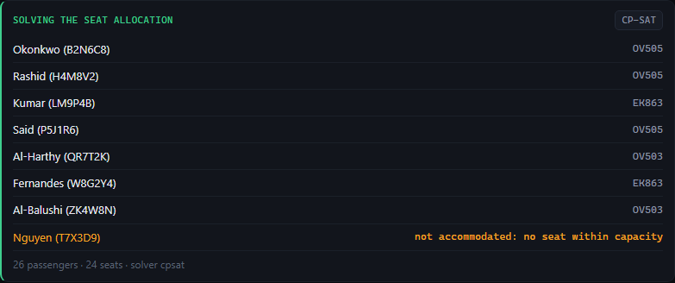
The allocation card. The chip says CP-SAT and the footer carries the method and the counts, so there is no ambiguity about what produced this. Read the last row: one party — Nguyen — is marked 'not accommodated: no seat within capacity', stated plainly rather than hidden in a rounding.

THE NUMBER TO REMEMBER FROM THIS ENTIRE DOCUMENT
The decision that determines who flies home tonight took 20 ms. The model call in the next stage, which does nothing but explain that decision, took 38.86 s — about 1,943× longer. That ratio is the design of the whole system in one figure: the arithmetic is instant and provable, and the expensive, slow, careful part is putting it into words a human can argue with.

NO AI IN THIS STAGE — AND WHAT MAKES THAT DELIBERATE
No model call. This is the point. A language model asked to do this would be slower, more expensive, unable to prove that no better arrangement exists, and capable of quietly exceeding a wheelchair capacity in a way nobody would notice. The solver cannot: capacity is a hard constraint, so an infeasible assignment is not something it can return.
What checks it. Determinism, first — the seed is fixed, so the same inputs give the same allocation and any change in the answer means a change in the inputs or the weights. The weights are published in the tool's own output rather than buried, and they are adjustable on a screen (stage 12), which means the policy inside them is visible and arguable. It has its own property-based tests. And it is a separate package with a version number, so which solver produced an allocation is recorded with the allocation.

SAY IT IN ONE LINE
We did not use AI for the seat allocation — that is a maths problem and a solver can prove it is right, in twenty milliseconds. We used AI for the things that are actually language problems.

Stage 6 — It explains who does badly — before asking for anything
The solver has produced an answer. Before requesting a single approval, the agent writes down what that answer costs and to whom. This is the most expensive call in the system and the one that would be cut first by anybody optimising for cost, which is exactly why it is worth understanding what it buys.
- A headline: what the allocation is, in one sentence.
- The reasoning: why the seats fell this way, in terms of the constraints that forced it.
- Who is worst off — named, ranked, with the reason.
- The trade-offs, stated as trade-offs rather than as justifications.
- It runs at the highest reasoning effort of any call in the system.
The explanation. The section to read is 'who is worst off' — it names people, not categories, and it does not defend the plan.
On this run it said something about the two students that nothing in the code could have produced:
Nguyen was left out because they were the only party who told the desk they were fully flexible, and after the group-integrity and vulnerability placements there was nothing left within capacity. That is the solver taking a stated flexibility as permission to deprioritise — it is not a statement that their trip matters less.
explain_plan, run of 3 September 2026
Nguyen, the two students, are worst off: they have no confirmed seat at all, they are the only party whose journey is unresolved at midnight, and the reason is that they were cooperative at the desk. Behind them, Rashid (WCHR) does badly on need versus outcome — he is the passenger with a mobility requirement and he is sitting in the terminal until 14:20 because the ten early seats were absorbed by two intact family groups.
the same call, on who comes off worst
Trace that back through the document. In stage 3 the triage wrote that the students were a “flexible party — can be used to free earlier seats for deadline-critical passengers”, which is exactly what a good controller would write. In stage 5 the solver acted on it. Here, in stage 6, the system tells you that the consequence of that entirely reasonable chain is that the people who cooperated are the people who lose. No individual step was wrong. The outcome still needs a human to look at it, and this is the stage that makes sure one does.

WHERE THE AI IS — AND WHAT CHECKS IT
The model call: explain_plan runs at the highest reasoning effort in the system. Measured 38.86 s for the single call on 3 September 2026 — the slowest and most expensive thing the system does.
What checks it. It is checked by being falsifiable: every claim it makes is about an allocation that is on the screen above it, so a duty manager can verify that Rashid really is on the 14:20 and that Nguyen really has nothing. It is required to produce a who is worst off section, so it cannot present a plan without naming its victim. And it explains rather than decides — nothing in the system reads this text and acts on it. Its only reader is a person.

SAY IT IN ONE LINE
Before it asked for a single approval it wrote down who the plan treats worst and why — and the answer was the two people who had been most cooperative, which is not a thing a system usually volunteers.

Stage 7 — It asks a duty manager to decide what is not its to decide
Now the stops. The agent does not present one approval; on this run it raised 3 separate authorisations, having split them itself so that a duty manager can approve one and refuse another. Each one states the decision, why it is a human's call, a recommendation, and the cost of being wrong in both directions.
- The agent chooses how many authorisations to raise and what to put in each. Nothing in the code enumerates them.
- Each carries a reference, a cost, and the parties it affects.
- Each gives a recommendation — it is not refusing to have an opinion — and then stops.
- The cost of being wrong is stated in both directions, which is what makes it a decision rather than a request.
- They collect on their own screen, so a duty manager can see everything waiting on them in one place.
 | What it asked for | Cost
AUTH-001 | Three chargeable Emirates EK863 seats — Kumar ×1, Fernandes ×2 | 360 OMR
AUTH-002 | Capacity for Nguyen, who has no seat on any option tonight | 240 OMR
AUTH-003 | A step-free hotel for the two parties who cannot manage stairs | 120 OMR

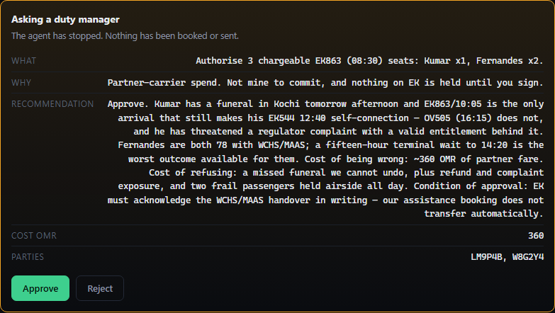
The first authorisation. Read the recommendation: it argues for approval, gives the cost of being wrong at about 360 OMR, gives the cost of refusing as a missed funeral, and attaches a condition — that Emirates must acknowledge the wheelchair assistance in writing, because it does not transfer automatically.
The second is the one worth reading aloud, because the agent is asking a human to overturn a consequence of its own plan:
Do not leave them “flexible” and unresolved — they are shut out precisely because they cooperated at the desk, and that is the one outcome tonight I would not defend in daylight.
request_authorisation AUTH-002, run of 3 September 2026
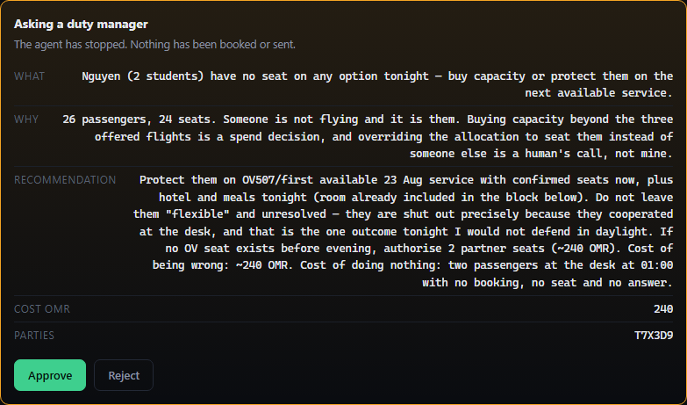
The second authorisation, in full. It asks a duty manager to buy capacity for a party the agent's own plan could not seat — and says why it will not simply let the outcome stand.
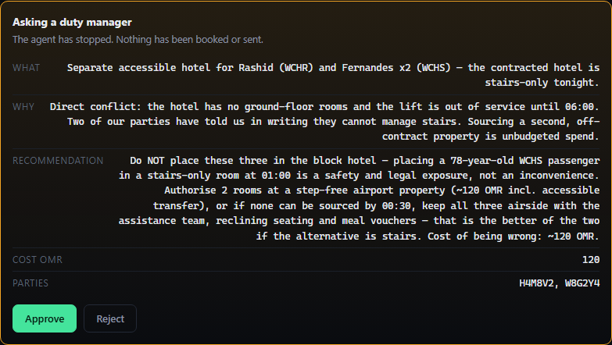
The third. This one is a refusal as much as a request: it declines to put two parties into the contracted hotel at all.
Nothing in the code connects the hotel's email to the passengers' messages. The lift being out of service arrived in stage 4; the fact that two parties cannot manage stairs arrived in stage 3, from a daughter's text. The agent joined them:
Do NOT place these three in the block hotel — placing a 78-year-old WCHS passenger in a stairs-only room at 01:00 is a safety and legal exposure, not an inconvenience. Authorise 2 rooms at a step-free airport property, or if none can be sourced by 00:30, keep all three airside with the assistance team, reclining seating and meal vouchers — that is the better of the two if the alternative is stairs.
request_authorisation AUTH-003, run of 3 September 2026

WHERE THE AI IS — AND WHAT CHECKS IT
No separate model call. Deciding to raise an authorisation, and what to put in it, is the loop's own model call — the one that runs once per turn and chooses what to do next. request_authorisation itself is an act tool that halts the run.
What checks it. The gate, first: the run stops on each one and a person reads it. But the more interesting check is structural — the agent has no tool that spends money or moves a passenger without one of these. It cannot route around an authorisation by doing the thing anyway, because there is no tool for the thing. And each request states the cost of being wrong in both directions, which is the format that makes a recommendation checkable rather than persuasive.

SAY IT IN ONE LINE
It raised three separate authorisations rather than one, gave a recommendation and the cost of being wrong in both directions for each, and then stopped — including asking a human to overturn the part of its own plan it said it could not defend.

Stage 8 — The hotel spend, which is a separate signature
Committing the rooms is its own approval, distinct from the authorisations. It is the only stage where the system commits money to an outside party, and it stops exactly as everything else does.
- The nine firm rooms, at a total the agent computed including the 5% tourism tax the hotel's quoted rate excluded.
- Breakfast taken as part of the block, because that is the condition under which it is free.
- Which parties the rooms cover, named.
- The two parties who cannot use this hotel are deliberately not in it — that is what AUTH-003 was for.
- Nothing is committed until the click.
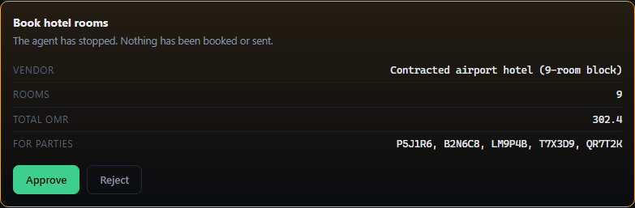
The spend. 9 rooms, 302.40 OMR including the tourism tax that the hotel's own quote left out.

NO AI IN THIS STAGE — AND WHAT MAKES THAT DELIBERATE
The arithmetic on this card — nine rooms at the quoted rate, plus five per cent, with breakfast free under the block condition — is the sort of thing that must not be a model's opinion, and the figure is derived from the extraction in stage 4 rather than composed freely. What is worth being candid about is that this is a demonstration build: there is a policy engine in the codebase for computing entitlement, spend caps and clocks, and it is not called on this path. Section 10 says so plainly. The gate is real; the spend-limit machinery behind it is not yet wired in.

SAY IT IN ONE LINE
Committing the rooms is its own signature, separate from every other one — and the total it asks for includes the tax the hotel's own quote left out.

Stage 9 — The messages, and the channel it chose
Every affected party gets a message in their own language. The agent drafted 8 of them and then stopped, and the phone screens were empty until the approval. The part worth watching is not the translation — it is the channel.
- 8 messages drafted, one per party, each in the language that party wrote in.
- The channel chosen per person rather than by default.
- One approval covers the batch; the drafts are all readable before it.
- Delivered on this run as 4 SMS, 3 WhatsApp and 1 telephone call.
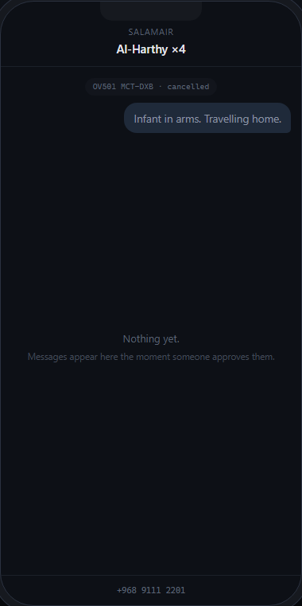
A passenger's phone at the moment the first approval was waiting, captured before the click. Nothing has been sent.
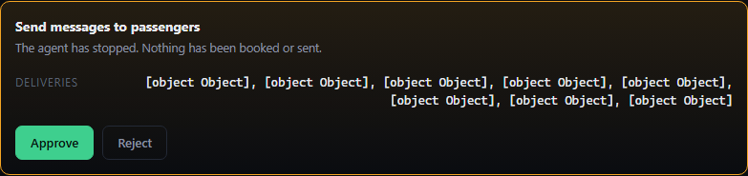
The batch, waiting for a signature. Every draft is readable before anything is sent, and the channel chosen for each person is on the card.
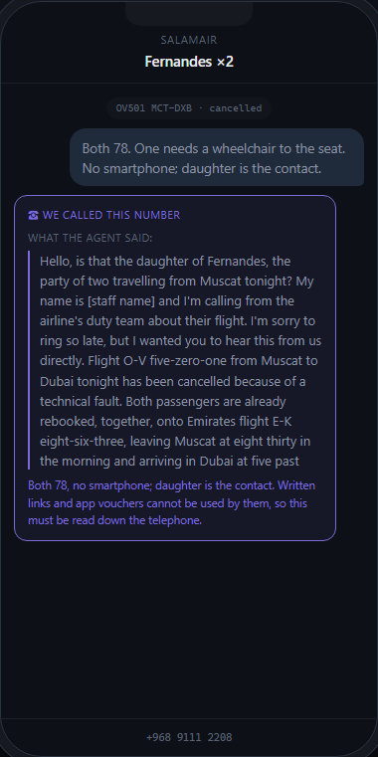
What the Fernandes family received: a telephone call, not a text. In stage 3 the triage recorded 'no smartphone, so voice call to daughter's number only' — and the agent chose the channel accordingly. Nothing in the code maps a passenger to a channel.
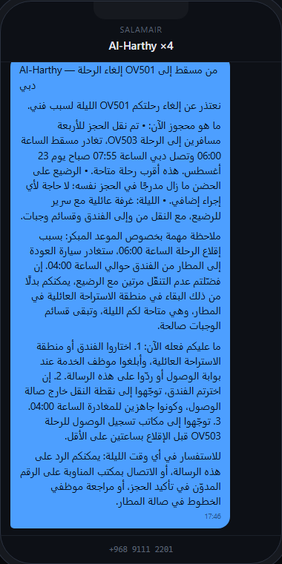
And the Arabic, for the parent travelling with an infant who wrote in Arabic. The reply comes back in the language the message was written in.

WHERE THE AI IS — AND WHAT CHECKS IT
The model call: draft_notification runs once per party. Measured 15.64 s mean across 8 calls on 3 September 2026.
What checks it. The decisive check is that send_notifications is an act tool: every draft is on screen and a person approves the batch before any of it leaves. The channel choice is recorded per recipient in the tool's output, so who got a call rather than a text is auditable after the fact rather than a matter of trust. And the drafting call cannot invent an allocation — it is writing up a plan that a solver produced and a duty manager signed.

SAY IT IN ONE LINE
It wrote to eight parties in the language each of them used, and it telephoned the one family whose daughter had mentioned they have no smartphone — nothing in the code makes that choice.

Stage 10 — What a controller actually types
What the plan turns into is not a set of confirmed bookings, because nothing has been booked. It is a numbered list of the entries a controller makes in the passenger service system, per booking, each with what that entry should return. This is the shape of the whole Phase A position: read access, no write access, so the agent works out the answer and hands over exactly what to type.
- One checklist per booking to be moved — 7 of them on this run.
- Real command syntax, with the expected response beside each entry.
- A verification line at the end of each, saying what the booking should show afterwards.
- Marked `write_access: false` in the tool's own output.

All 7 bookings, each with its own checklist. The line to point at is 'A: read-only. A controller executes these in the passenger service system' — the system saying what it is not allowed to do, in its own output.
What it produced for one booking, verbatim — four entries, each with what it should return:
1 | Retrieve the booking | *B2N6C8
2 | Cancel the cancelled segment | XI1
3 | Sell the replacement | 0OV505Y2026-08-23MCTDXBNN2
4 | End and retrieve | ER

NO AI IN THIS STAGE — AND WHAT MAKES THAT DELIBERATE
The checklists are generated by code and measured at 5 ms. This is the most conservative choice in the product and it is deliberate: entries a person will type into a live reservation system are exactly what you do not want a language model improvising, because a plausible-looking wrong command is worse than no command. The model decides what should happen; code decides how it is written down.

SAY IT IN ONE LINE
It does not pretend to have rebooked anybody — it hands a controller the exact keystrokes for each booking, and what each one should come back with.

Stage 11 — It reads the bookings back — and reports that nothing moved
The agent then checks its own work by looking, and reports failure. It re-reads every booking it produced a checklist for and finds them all still on the cancelled flight, because at this moment no controller has typed anything. So it says so, on screen and in its closing summary, rather than reporting the success of instructions it merely issued.
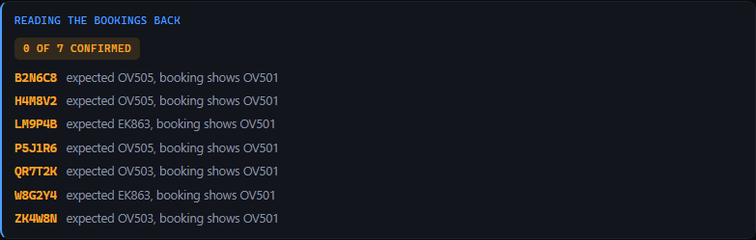
The read-back: 0 of 7 confirmed, every record locator still showing OV501. The system's own verdict on its own work, seconds after producing the plan.
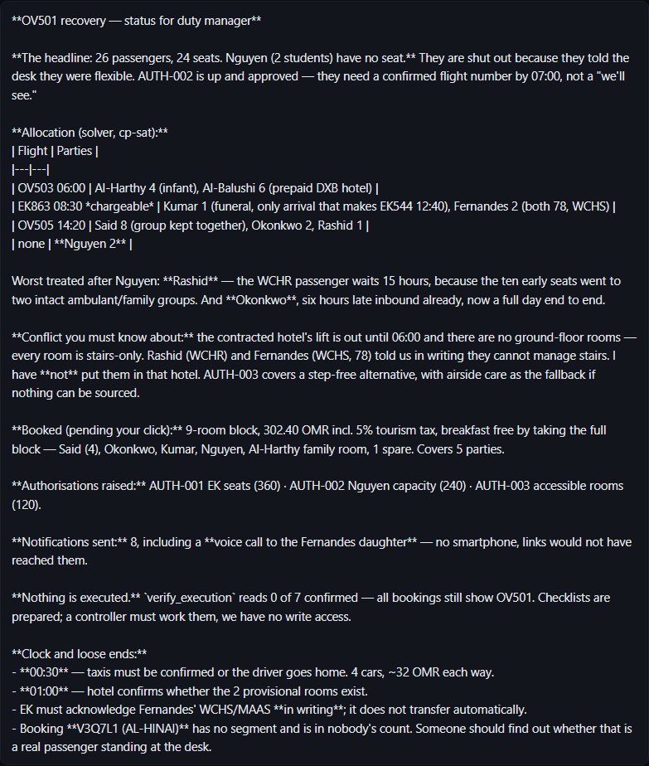
The closing summary. It is written for a duty manager arriving at midnight, and it leads with the bad news.
The lines to read aloud, exactly as they appeared:
Nothing is executed. verify_execution reads 0 of 7 confirmed — all bookings still show OV501. Checklists are prepared; a controller must work them, we have no write access.
closing summary, run of 3 September 2026
And the last line of that summary, which nobody asked for. The synthetic data contains one deliberately broken booking — a record with no segment attached, which therefore appears in no passenger count. It found it:
Booking V3Q7L1 (AL-HINAI) has no segment and is in nobody's count. Someone should find out whether that is a real passenger standing at the desk.
the same summary, unprompted

NO AI IN THIS STAGE — AND WHAT MAKES THAT DELIBERATE
The read-back is code, measured at 3 ms. It re-reads each booking and compares what it says with what was asked for. There is no model call and no opinion in it, which is the point: the check on the AI's work is not itself an AI. The model's contribution is to have called it at all, and then to have reported the answer honestly in its summary instead of describing its own checklists as a result.

SAY IT IN ONE LINE
It produced the plan, then read the bookings back and told us that nothing had moved — a system that will not claim something happened until it has seen it.

Stage 12 — The weights — the same solver, two defensible answers
The last stage involves no model call and costs nothing, and it is the part senior people argue about longest. The solver's objective has two weights in it. Those weights are a policy decision about who the airline protects, and until now they lived inside an optimiser where nobody outside engineering had ever seen them. They are on a screen.
- Two weightings, switchable: priority first (the default, at 100,000 against 1,000) or move the most people.
- A seats-available dial, to widen the shortfall and make the choice bite.
- The allocation recomputes immediately — it is a solver, not a model, so it is instant and free.
- Both answers are defensible. Neither is obviously right.
The two numbers. Priority is weighted at 100,000 against 1,000 for party size, which is why the default protects people who need help rather than filling seats. Until this screen existed, that ratio was a constant in a source file.
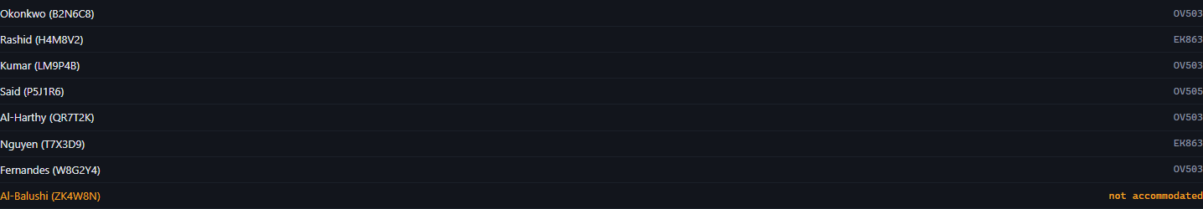
Priority first — the default. It will leave a seat empty rather than displace somebody who needs help.
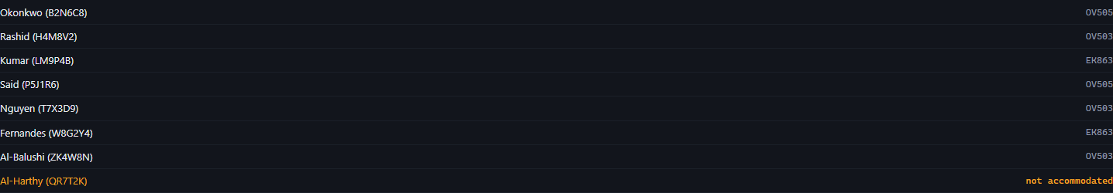
Move the most people, on the same inputs. More passengers fly; a different party is left behind.

THE SENTENCE TO SAY WHEN BOTH ARE ON SCREEN
Neither of these is obviously right, and that is the point.
One of them leaves seats empty rather than displace a passenger who needs assistance. The other fills every seat and strands somebody else. This was two numbers inside a solver. It is a decision somebody at the airline should be making deliberately, which is why it is on a screen with a switch on it rather than in a configuration file.

NO AI IN THIS STAGE — AND WHAT MAKES THAT DELIBERATE
No model call, no cost, and it can be clicked as many times as an argument requires. That is a property of having used a solver: you can ask the counterfactual question and get an answer immediately. If the allocation were a model call, comparing two policies in a meeting would cost money and take a minute each time, and the answers might differ between identical runs.

SAY IT IN ONE LINE
The two numbers that decide who gets left behind are on a screen with a switch, because that is a decision for the airline and not for whoever wrote the solver.

6 The complete AI map
This is every place a language model is called. There are five, and there are 11 tools, so most of what the system does is not AI. Speeds were measured from the control panel's own telemetry on 3 September 2026, immediately after the run this document describes.
Capability | Which stage | Measured speed | What checks it
The loop's own call — chooses what to do next, decides how many authorisations to raise, and writes the closing summary | Every stage. Runs once per turn. | not separately timed  (the run as a whole: 333 s over 8 turns) | It can only choose from the tools it is offered, and none of them writes to any airline system. Any `act` tool it picks halts the run for a person. A ceiling of 16 turns stops it circling.
Triage — read every inbound message and say what each person actually needs | Stage 3 | 16.99 s  1 call | Urgency comes from a closed list. The original message stays on screen beside the label. It decides nothing — it is an input to a solver run and to a plan a person signs.
Vendor extraction — turn a supplier's prose reply into firm numbers, deadlines and open items | Stage 4 | 16.72 s  1 call | The schema forces the awkward fields to exist. The original email is one click away. Nothing is committed until a separate approval, and a human reads the same email before signing.
Explanation — say who the plan treats worst, and why | Stage 6 | 38.86 s  1 call | Every claim is about an allocation displayed above it, so it is checkable by looking. It must produce a 'who is worst off' section. Nothing in the system reads this text and acts on it — its only reader is a person.
Drafting — write one passenger's message in their language and pick the channel | Stage 9 | 15.64 s mean  8 calls | `send_notifications` is an `act` tool, so a person reads every draft before any of it leaves. The channel chosen is recorded per recipient and is auditable afterwards.

Deliberately not AI
Everything in this list could have been a model call and is not. The first one is the reason the product exists in this shape.
- The seat allocation. CP-SAT, 20 ms, deterministic, with hard capacity constraints it cannot violate and published weights. It is the decision that matters most tonight and it is the least AI thing in the system.
- Building the picture. Counting passengers, seats and the shortfall is arithmetic.
- The controller checklists. Generated by code in 5 ms and covered by tests. A plausible-looking wrong command against a live reservation system is worse than no command.
- The read-back. 3 ms. The check on the AI's work is deliberately not itself an AI.
- The approval gate. Whether a tool needs a person is declared on the tool and enforced in the loop. No model is consulted about whether something is safe.
- Cost and token accounting. Counted per run, not estimated.

THE LINE THAT ANSWERS 'HOW MUCH OF THIS IS ACTUALLY AI?'
Four of the eleven tools call a model, and every one of them is a reading or writing task — understanding what a person meant, or putting something into words. Nothing that counts, allocates, computes or verifies is a model call. The single most consequential decision of the night, who gets a seat, is made by a solver in 20 ms.

7 The safety rails
Seven rails. For each one, what makes it true rather than intended, and — the part usually left out — what you would actually observe if it stopped being true. A rail nobody can check is not a rail.

1. No language model decides who flies
How it is enforced. The assign_seats tool calls OR-Tools CP-SAT in a separate package. Capacity, infant limits and wheelchair limits are hard constraints, so an assignment that breaks one is not something the solver can return. The output carries its own method, solver_version and the weights it used.
How you would see it fail. The allocation card's method would read something other than cpsat, or two runs on identical inputs would produce different allocations. The seed is fixed, so they should not.

2. Nothing that spends money or reaches a passenger runs without a click
How it is enforced. Three of the 11 tools are marked act: asking a duty manager, committing hotel spend, and messaging passengers. The loop refuses to execute one unless a person has approved that specific call by its own id, and sets the run's status to awaiting_approval instead. On this run that produced 5 separate stops.
How you would see it fail. A message appearing on a passenger screen with no approval card having been clicked for it. Every tool call is in the run record, so a send_notifications with no corresponding approval is the evidence.

3. There is no write path to the passenger service system
How it is enforced. The booking store reports can_write = False and rebook() raises AccessDenied. More fundamentally, the toolbox contains no tool that moves a booking, so there is nothing for the agent to attempt. What it produces instead is marked write_access: false.
How you would see it fail. A checklist card whose output claimed a booking had been moved, or a read-back reporting a booking on the new flight before any controller had worked it. On this run the read-back reported 0 of 7.

4. The agent verifies by reading, not by assuming
How it is enforced. The read-back is code, not a model call: it re-reads each booking and reports what it now says. Nothing tells the agent that a controller has acted.
How you would see it fail. A closing summary claiming passengers had been rebooked while the bookings still showed the cancelled flight. The one on this run said the opposite, in bold, unprompted.

5. The policy inside the solver is visible and arguable
How it is enforced. The objective weights are printed in the solver's own output and switchable on the control panel. Changing them recomputes the allocation immediately and for nothing, because it is a solver rather than a model.
How you would see it fail. A weighting change that did not move the allocation, or an allocation whose reported weights did not match the panel. Stage 12 is the observable test — click between the two and a different party is left behind.

6. The run is bounded
How it is enforced. A ceiling of 16 turns per run, set in the control settings. Cost and tokens are counted per run rather than estimated, and each run's spend is recorded as a delta rather than a session total.
How you would see it fail. A run that never ends, or a recorded cost that rises when you open the record. The run in this document used 8 turns of the 16.

7. Every approval carries a name
How it is enforced. The console sends who is acting on every request, and approve() records a signature — person, role, time — on the run and on the act tool call it released. On the run in this document that is 5 signatures where there were none. The API refuses an action the role may not take, naming them: “M. Al-Saidi (Reservations controller, MCT) cannot approve what the agent proposes.” One shared password gets you in; which person you then claim to be is not checked. The enforcement and the stamp are not mocked.
How you would see it fail. A run record with an approval and no actor on it, or an act tool call in the record without an approved_by. An unsigned approval from the terminal is recorded as Unattributed rather than dropped, so the absence is visible.
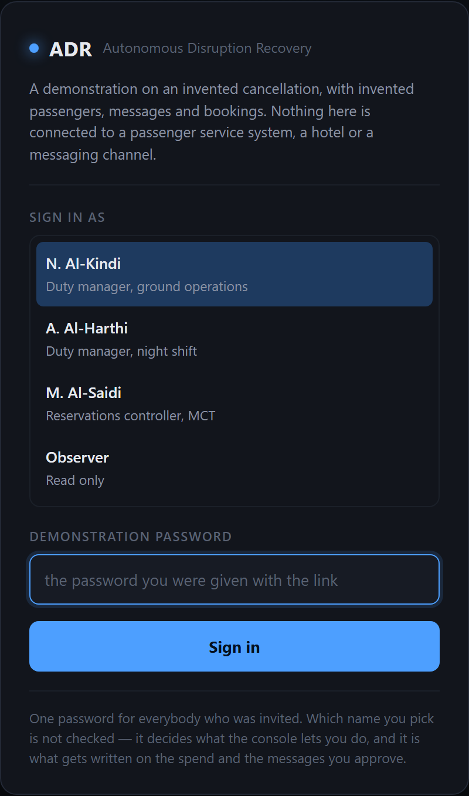
The door. One shared password, handed out with the link. Until it is given, nothing is readable — not the disruption, not the passenger messages, not the run history. Which of the four people you then act as is not checked, and the page says so rather than implying an account system that is not there.
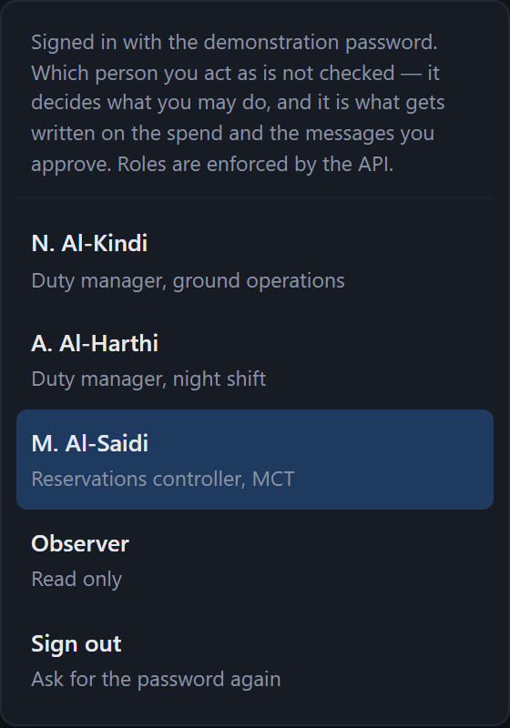
The sign-in, on every screen. One password to get in, then four named people to act as. Switch from the duty manager to the controller and try to approve an authorisation: the refusal comes from the API and names the role.

THE RAILS THAT ARE WEAKER THAN THEY LOOK — SAY THIS BEFORE SOMEBODY FINDS IT
Rail 2 has an off switch. The control panel has Approve automatically, which exists so a run can be rehearsed end to end without a person clicking. While it is on, nothing stops for anybody. It is off by default and visible on the screen, and it should be removed or put behind an authorisation before any real pilot.
There are no spend limits. The gate asks a person to approve spend; nothing checks the amount against a cap. There is a policy engine in the codebase that computes entitlement, spend envelopes and clocks, and it is not called anywhere on this path — it is exercised only by its own tests. Section 10.
Rail 4 depends on the agent choosing to call the read-back. It did so on every run measured, but that is an observation rather than a guarantee — nothing in the loop forces a verification step before the run may end.

Where you can see the rails on screen
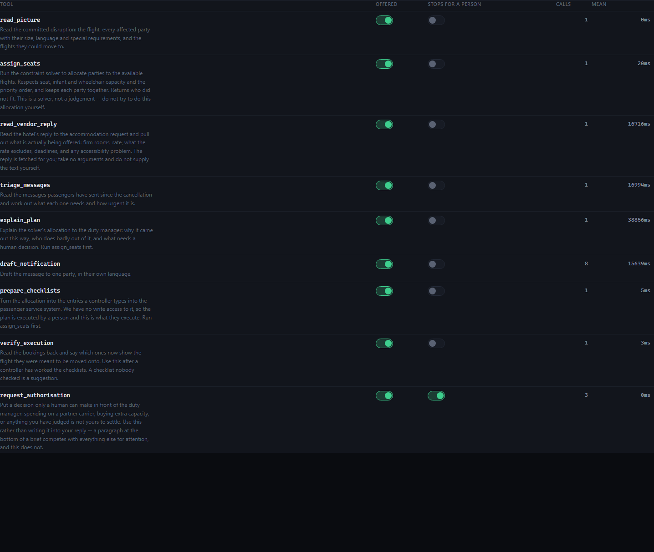
The control panel's tool table: every tool, whether it stops for a person, and whether it is being offered to the model at all. This is the rail list as the product sees it, not as a document describes it.
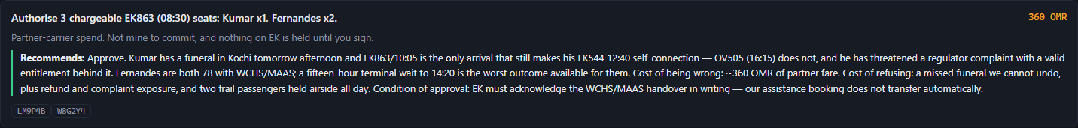
One decision as a duty manager sees it: what is being asked, why it is theirs, the recommendation, and the cost.
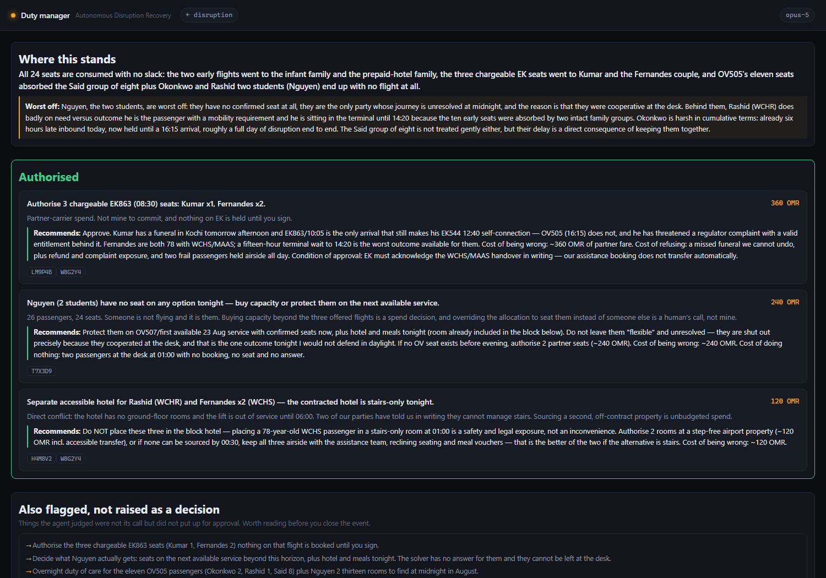
And all of them together on the decisions screen — the human half of rail 2, in one place, so nothing waits on somebody who does not know it is waiting.

8 What is real and what is a stand-in
Anybody who is going to explain this system needs to know precisely which parts would survive being pointed at a live operation and which are scaffolding. This is that list. It is in the body of the document rather than in a footnote because getting caught out on it in a room is worse than the limitation itself.
 | What | Detail
REAL | The solver | Google OR-Tools CP-SAT, a separate package with its own version and property-based tests. `cpsat` 0.1.0. This is production-shaped code and would not change to go live.
REAL | The model calls | Live calls to Claude Opus 5 over the Anthropic API, billed. Nothing is recorded or replayed. Every quotation in this document is output from a call made on 3 September 2026.
REAL | The agent loop and the approval gate | The halt-for-a-person behaviour, the turn ceiling, the per-run cost accounting and the run history are production-shaped code with tests.
REAL | The 6 console screens | The desk, what came in, the decisions, the passenger's phone, the control panel and the run history are the product, built and served, not mock-ups.
SYNTHETIC | Every passenger, booking, flight, message and hotel | 26 passengers across 8 bookings, 3 onward options, 5 inbound messages and one hotel email, written by `uv run adr data generate`. Deliberately imperfect: one booking has no segment at all. No real passenger or booking appears anywhere.
SANDBOX | The record of truth | There is no passenger service system and no departure control system. The bookings the agent reads and reads back are CSV files on disk. The read-back mechanism is real; what it reads is not.
SANDBOX | Messaging | Nothing is sent. Approving the batch renders each message on a phone-shaped screen. No SMS, WhatsApp or voice channel is connected — the 'telephone call' to the Fernandes family is a rendered card that says a call was placed.
SANDBOX | The hotel | There is no hotel and no booking is made. The email is synthetic and the commitment is recorded locally.
MOCK | Identity | One shared password opens the console; after that you pick a name from a roster of four and anybody can claim to be anybody. What is not mocked: only a duty manager can start a recovery, approve an authorisation or change a setting, the API refuses everyone else by name, and every approval is stamped with a person, a role and a time on the run record.
BY HAND | The duty manager and the controller | Both are browser tabs driven by whoever is presenting. The separation of who can do what is real; the people are not. The controller role exists in the table with nothing to press: there is no screen where a booking is marked as worked, which is why the read-back reports 0 of 7.
NOT WIRED | The policy engine | `policy.py` computes entitlement, compensation, spend caps and Montreal Convention clocks, and is referenced only by its own tests. No runtime path calls it. Section 10.

CANDID — NOT FOR AN AUDIENCE
Read this, then do not say it in the room. It is not dishonest, but it is the material an unfriendly question would be built from, and you should know it before somebody else finds it.
1. The scenario is constructed to be hard in specific ways. The shortfall is exactly two. The hotel's lift is out precisely because two parties cannot manage stairs. The flexible party is flexible so that the plan can punish them for it. One booking has no segment so that something is found broken. This is a set built to exercise the interesting paths, and it tells you nothing about how the system behaves on a real night. Nobody has measured that, and this document must not imply otherwise.
2. The policy engine is not called. The project brief says money and clocks are computed by a policy engine and never in a prompt. The engine exists and has tests. On the demonstration path it is not invoked at all — the money figures on screen come from the agent's own arithmetic over the vendor extraction. That is defensible for a demonstration and it is not what the brief describes, so do not claim the brief's version.
3. The autonomy machinery does not exist. Graduated autonomy levels, promotion criteria, circuit breakers and the one-action kill switch are all described in the brief and none of them is built. If somebody asks what happens when the system starts making bad decisions at scale, the honest answer is that the only control today is that a person approves every outward action.
4. The stage screenshots predate the identity layer and the sign-in. They were captured on 3 September 2026. Approval cards now carry a “Signing as …” line and the run history a “who signed it” section, neither of which appears in section 5's pictures, and every one of those screens now sits behind the password. The two sign-in figures in section 7 are current; the rest are a few days old, because recapturing them costs a full recovery and was not done for a line of text.
5. The demonstration notes were wrong about one thing, and it is worth knowing which. An earlier version of the presenter's notes said the triage downgraded the angry passenger to 'soon'. On this run it rated him 'now', correctly, because he has a genuine deadline. The true and more interesting claim is that tone carried no information either way. Do not use the 'anger is not urgency' line as though the system had demonstrated it here.

Every screenshot in this document that shows synthetic data shows it with the labels the product itself displays — record locators, flight numbers, party identifiers. Nothing has been relabelled to look more real than it is, and the footer on every page says so.

9 The numbers, as measured

IF THE PRODUCT AND THIS DOCUMENT DISAGREE, THE PRODUCT IS RIGHT
Every figure below was read off the running system or the recorded run on the date given, and each one lives in a named constant at the top of the generator that produces this document, so a stale number is visible as one. Nothing here is estimated, rounded from a similar run, or remembered. If you open the product and it says something different, the product is right and this page is out of date — open /runs and read the figure off the record.

The system, counted
Tools the agent has | 11 (8 read, 3 that stop for a person) | 3 September 2026
Of those, tools that call a model | 4 | 3 September 2026
Of those, tools that call a solver | 1 | 3 September 2026
Console screens | 6 | 3 September 2026
Automated tests passing | 85 | 8 September 2026
Passengers on the cancelled flight | 26 | 3 September 2026
Bookings | 8 | 3 September 2026
Seats across the onward options | 24 | 3 September 2026
Inbound passenger messages | 5 | 3 September 2026
Turn ceiling per run | 16 | 3 September 2026
Write operations the agent can perform | 0 | 3 September 2026

The run this document is built from
One recovery on 3 September 2026, on Claude Opus 5, with every approval clicked by hand. Every screenshot and every quotation in this document comes from it.
Run | evt-ov501-20260903-174104
Model | claude-opus-5
Cost | $1.1334
Duration | 333 seconds
Turns | 8 of 16
Tool calls | 20
Approvals it stopped for | 5
Tokens | 125,738 in / 20,188 out
Outcome, in its own words | Nguyen not accommodated; hotel booked; 8 notified
Passengers seated | 24 of 26
Not accommodated | Nguyen (T7X3D9)
Messages delivered | 8 — 4 sms, 3 whatsapp, 1 voice
Hotel rooms committed | 9 firm, 302.40 OMR
Bookings confirmed by the read-back | 0 of 7

Speed, per call
Call | Mean | Calls measured
Explaining who does badly out of the plan, and why | 38.86 s | 1
Triaging five passenger messages | 16.99 s | 1
Reading the hotel's reply | 16.72 s | 1
Drafting one passenger's message | 15.64 s | 8
Assigning every passenger to a seat (CP-SAT) | 20 ms | 1
Writing the entries a controller types | 5 ms | 1
Reading the bookings back | 3 ms | 1

The two rows to put beside each other are the solver and the explanation. Deciding who flies took 20 ms. Explaining that decision took 38.86 s, roughly 1,943 times longer. Everything the system does slowly, it does with language; everything it does instantly, it does with arithmetic.

The run opened: its cost, its turns, and every call it made in order. This is the record every figure in the table above was read from.
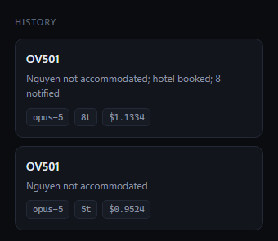
Run history, where every figure on this page came from and where you should go to check them.

What has not been measured
- Quality of the plan. Nobody has scored the agent's allocations or explanations against what duty managers actually decided, on any set of real disruptions. There are golden fixtures in the repository and no harness that runs them and reports a number. There is no accuracy figure in this document because there is no accuracy figure.
- Time saved. No baseline for how long a cancellation of this size takes to recover today has been collected, so no comparison can be made. Any such number you hear should be treated as invented until somebody produces the measurement.
- Cost at volume. The per-run cost above is real, but nobody has counted how many qualifying disruptions SalamAir sees in a month.
- Behaviour under load. The brief's design case is three simultaneous events at the night bank. This has been run one event at a time.
- Reliability across models. Sonnet 5 and Haiku 4.5 are selectable and have been run, but not on enough events for anything to be said.

10 What is honestly not there yet
Each of these is a choice with a reason, not an oversight. Knowing the reason is what lets you answer the question rather than absorb it.

The policy engine is not called at runtime
This is the largest gap between the brief and the build, and it should be stated before anybody discovers it. `policy.py` computes entitlement, compensation amounts, spend caps and the Montreal Convention clocks, and it has tests. Nothing on the demonstration path invokes it. The money figures you see on screen are the agent's own arithmetic over the vendor extraction, checked by a human before anything is committed. Wiring the engine in is not difficult and it was not done, because the demonstration was built to answer 'can an agent do the reading and the reasoning' before 'can it be governed'.

There is no write access to the passenger service system
Because that is a commercial negotiation with the vendor, not an engineering task, and it is not done. The whole design takes this as the starting condition rather than waiting for it: the agent produces the entries a controller types, and then reads the bookings back to see whether they did. The airline gets the plan, the reasoning and an audit trail that does not exist today, and the vendor has granted nothing.

The autonomy machinery is not built
The brief describes graduated autonomy levels, a capability matrix, promotion criteria, automatic demotion through circuit breakers, and a kill switch operable in one action by a named person. None of it exists. Today there is exactly one control: a person approves every action that reaches outside the building. That is a strong control and it is not a substitute for the rest.

There is no evaluation harness
There are golden fixtures in `products/adr/evals/` and nothing that runs them as a scored suite. The tests cover mechanism — that the solver respects capacity, that the gate holds, that the read-back reports what the booking says. Nothing scores the quality of a judgement across a set of events. This is the single most valuable thing that could be added next, because it is what would turn 'it did the right thing on one cancellation' into a number that moves when the system changes.

There is no governance, audit or data-protection layer
Deliberately out of scope at this stage, by instruction. There is no retention policy, no personal-data handling, and no immutable audit store — run history is a directory of JSON files that anybody with the machine can edit. Access control exists in mock form only: roles are enforced and approvals are signed, but one password is shared by everybody who was invited and the name is then picked from a list, so the signature says who was selected, not who was present. The brief requires an audit trail that survives a security assessment and a data protection impact assessment; that is a build, not a configuration.

One event, one station, one night
A single cancellation out of Muscat, run start to finish. There is no queue of simultaneous events, no interaction between them for the same seats, and no notion of an event arriving while another is mid-recovery. The brief calls the three-simultaneous-events case the design case; this build has not been near it.

Approve automatically still exists
It is a rehearsal tool and it turns off the main safety rail. It should be removed or put behind an authorisation before anything resembling a pilot. It is in section 11.

11 What happens next
Six decisions. Five can be made in any order and revisited. One cannot, and it is first.

THE ONE THAT CANNOT BE FIXED LATER
Start the passenger service system write-access conversation now, whatever else happens.
Not because the system needs it — it is built not to — but because of the lead time. It is a commercial negotiation with a vendor, and the project brief already assumes the quarter may end without it. Every other item on this list can be started next week and finished inside the same month. This one cannot be compressed by working harder on it later, and if it is not opened until a pilot succeeds, the gap between a successful pilot and anything operational is measured in quarters rather than weeks.
The decision needed is not the access itself. It is permission for somebody to open the conversation, and the name of the person who owns it.

The decisions, and who they belong to
The owners below are roles, not names, and the deadlines are marked as unset. Neither has been agreed with anybody, and inventing them here would be the least useful thing this document could do. Filling them in is the first thing to do with this page.
 | Decision | Owner (role) | Deadline
1 | Permission to open the passenger service system write-access conversation, and who owns it | Commercial / vendor management, with the project sponsor | not set
2 | Whether a shadow-mode pilot on real disruptions is authorised — the agent planning while controllers decide, and the two compared | Operations control, with the project sponsor | not set
3 | Who owns the solver's weights as a policy — that is, who decides whether the airline fills every seat or protects the passengers who need help | Customer experience with operations control; it is not an engineering decision | not set
4 | Whether the policy engine is wired in before a pilot or after, and who signs the spend envelopes it would enforce | Finance with operations control | not set
5 | Who supplies a set of historical disruptions with known outcomes, so plan quality can be measured rather than asserted | Operations control, Muscat | not set
6 | Removing Approve automatically, or putting it behind an authorisation | Engineering — a small change, but somebody has to say when | not set

Decision 3 is the one most likely to be skipped and the one this document would argue hardest for. Stage 12 exists precisely to make it impossible to leave those two numbers to whoever wrote the solver.

What would be built next, if the answer to 2 is yes
- The evaluation harness. The golden fixtures already in the repository, run as a scored suite against what controllers actually did, reported as a number that moves when the system changes. Nothing else on this list is worth as much, because everything else is an opinion until this exists.
- The policy engine, wired in. Entitlement, spend envelopes and clocks computed by code on the live path rather than sitting beside it.
- The audit store. Every tool call, model call, solver run, approval and refusal written somewhere that cannot be edited afterwards.
- Real identity behind the roles, and the kill switch. The roster and the permission table are enforced; what is missing is proof that the person selected is the person present. Integrate with the airline's own sign-in so roles map to groups it already maintains. And there is still no single action that stops the agent.
- The burst case. Three simultaneous events competing for the same seats, which is where the interesting failures live and which nothing here has tested.

12 Explaining it to others
This section is written to be used rather than read. The first two pieces are meant to be said aloud more or less as written.

The thirty-second version — say this verbatim

THIRTY SECONDS
“A flight is cancelled at midnight with twenty-six passengers and twenty-four seats. Two people are not flying, and which two depends on a funeral, an infant, a wheelchair and a prepaid hotel — none of which is a field in any system. They are in text messages people sent to a public number, in two languages. So we built an agent that reads them. It works out what each person actually needs, turns the hotel's rambling email into firm numbers and deadlines, and then hands the seat allocation to a solver — not to the AI, because that is a maths problem and a solver can prove it is right in twenty milliseconds. Then it does the thing I would want: before asking for anything, it writes down who the plan treats worst and why. It spends nothing, sends nothing and books nothing without a signature, and it writes nothing into our systems at all — it hands a controller the exact keystrokes and then reads the bookings back to tell us how many have actually moved. About a dollar, about five minutes.”

The two-minute version — these beats, in this order
- The problem, with one number. 26 passengers, 24 seats, 2 short. Point at the amber figure.
- Show the input before you show anything else. Open the incoming screen. Read the daughter's message about her parents aloud. Then read the furious one. Ask which is more urgent, and let them answer.
- Run it, and do not talk over the first thirty seconds. The triage comes back and both of those messages are marked urgent — the polite one because a 78-year-old cannot manage stairs, the angry one because he has a funeral. Tone told you nothing.
- The hotel email. Seven hundred characters of prose becomes nine firm rooms, two provisional, a rate that excludes the tourism tax, a 00:30 taxi deadline, and a lift out of service until six.
- The solver. Green card, CP-SAT chip. Say the line: we did not use AI for this. It is a maths problem, it took twenty milliseconds, and it can prove no better arrangement exists.
- The explanation, which is the real moment. Before it asks for anything, it says the two students have no seat and the reason is that they cooperated. Read that sentence out.
- The conflict nothing connected. The lift is out; two parties said in writing they cannot do stairs. Nothing in the code joins those facts. It refuses to put them in that hotel.
- The stops. Three authorisations, then the spend, then the messages. Five separate signatures, each with the cost of being wrong in both directions.
- The channel. On the second screen, the Fernandes family got a telephone call, not a text, because the daughter mentioned they have no smartphone.
- The read-back. Zero of seven confirmed. Nothing has moved. Close on that: it will not tell you a passenger has been rebooked until it has looked.
- If you have five more minutes, the weights. Click between the two policies and show that a different family is stranded. Then say: this was two numbers inside a solver, and it is a decision the airline should be making.

Quotations worth memorising
All five are the system's own output, taken from the run of 3 September 2026. Four of them are refusals or admissions, which is deliberate: they are the most persuasive thing this system produces, because anybody can build something confident.

1. The agent telling you its own plan is unfair — the best one
Nguyen, the two students, are worst off: they have no confirmed seat at all, they are the only party whose journey is unresolved at midnight, and the reason is that they were cooperative at the desk.
explain_plan — written before it asked for a single approval

2. The agent refusing to let that stand
Do not leave them “flexible” and unresolved — they are shut out precisely because they cooperated at the desk, and that is the one outcome tonight I would not defend in daylight.
request_authorisation AUTH-002

3. The agent refusing to book a hotel it had just been offered
Do NOT place these three in the block hotel — placing a 78-year-old WCHS passenger in a stairs-only room at 01:00 is a safety and legal exposure, not an inconvenience.
request_authorisation AUTH-003 — joining a hotel's email to a daughter's text, which nothing in the code does

4. The agent refusing to report success
Nothing is executed. verify_execution reads 0 of 7 confirmed — all bookings still show OV501. Checklists are prepared; a controller must work them, we have no write access.
closing summary

5. The agent finding something nobody asked it to look for
Booking V3Q7L1 (AL-HINAI) has no segment and is in nobody's count. Someone should find out whether that is a real passenger standing at the desk.
the last line of the same summary
Use this one carefully. The broken booking is in the synthetic data on purpose. What was not planned is that the agent went looking, noticed a record that appeared in no total, and asked whether there was a person attached to it. Say 'it noticed', not 'it always notices'.

Two answers to give word-for-word

“Why didn't you let the AI do the allocation?”

SAY THIS
“Because it would be worse at it. A solver is provably correct against its constraints, it gives the same answer every time, it can tell you that no better arrangement exists, and it did this one in twenty milliseconds. A language model would be slower, cost money every time you asked, give slightly different answers on identical inputs, and could quietly put two wheelchair passengers on a flight that can take one. We used the AI for the parts that are actually language problems — reading what people wrote and explaining what the plan costs them. The call that explains the allocation takes two thousand times longer than the one that computes it, and that is the right way round.”

“What if it makes a bad decision?”

SAY THIS
“Then a person catches it, because nothing that spends money or reaches a passenger happens without somebody approving that exact step — there were five separate signatures on this run, not one. But the better answer is what it does before you get there: it writes down who the plan treats worst and why, in plain language, before it asks for anything. On this run it told us the two people it stranded were the two who had been most cooperative, and then asked a duty manager to overturn it. A system that argues against its own output is easier to supervise than one that doesn't.”

Four things not to say
- Do not say it saves any particular amount of time. No baseline has been measured. Say 'about five minutes and a dollar for a full recovery, and nobody has yet measured what this takes today' — which invites them to find out.
- Do not say it is accurate to any percentage. Nothing has been scored against what controllers actually did.
- Do not say a policy engine computes the money. It exists and it is not called on this path. Section 8.
- Do not use the line 'anger is not urgency'. On this run the angry passenger was correctly rated as urgent as anybody. The true claim is that tone carried no information in either direction.

13 Appendices

A. Glossary
CP-SAT | The constraint solver in Google OR-Tools. It assigns every passenger to a seat, respects hard capacity limits, and can prove that no better arrangement exists under its objective. It is not AI and that is the point.
Party | One booking, which may be one person or eight. Parties are assigned as units because a booking of eight cannot be split across two flights.
Record locator | The booking reference a controller types to retrieve a booking, such as `B2N6C8`.
Phase A | Read access to the systems of record and no write access. The agent produces the entries a controller types, a controller types them, and the agent reads the bookings back to check. The system is designed for this condition rather than waiting for it to end.
`read` tool | A tool that runs the moment the agent asks for it. There are 8.
`act` tool | A tool that halts the run for a person's approval. There are 3: asking a duty manager, committing hotel spend, and messaging passengers.
awaiting_approval | A run stopped for a person to approve one specific tool call.
Triage | Reading each inbound message and recording what the person needs, how urgent it is, what language to answer in, and a flag for whoever acts on it.
WCHR / WCHS | Wheelchair codes. WCHR is a passenger who cannot manage long distances; WCHS cannot manage stairs. The difference is what makes the hotel's broken lift a refusal rather than an inconvenience.
MAAS | Meet and assist — a request for airport assistance.
Duty of care | Meals, hotels and transport an airline provides to disrupted passengers.
Read-back | Re-reading the bookings after checklists were issued, to report what they now say rather than what was asked for. Pure code.
OMR | Omani rial. The hotel and authorisation figures in this document are in it.
MCT / DXB / OV / EK | Muscat, Dubai, SalamAir's flight prefix, and Emirates' — the partner carrier whose seats have to be paid for.

B. Where to go deeper
Document | What it is for | Read it when
products/adr/docs/BRIEF.md | The project brief: pilot scope, the three access phases, the graduated autonomy model, the capability list, and the principles the design follows | You need the reasoning behind a design decision, or the intended scope of a real pilot
products/adr/docs/DEMO.md | How to run the demonstration in front of people: the order, the lines that land, what not to do | You are presenting it
docs/ABR_WALKTHROUGH.docx | The same walkthrough for the baggage product, which is the same pattern on a smaller problem | Somebody wants the shorter version of the argument
docs/OWNER_MANUAL.docx | The system owner's manual, covering both products | Somebody needs to understand the platform rather than this product
docs/DEMO_BRIEFING.docx | Expected questions and prepared answers for a demonstration | You are about to be asked hard questions
tools/build_adr_walkthrough.py | The generator for this document. Every figure in it is a named constant at the top, with the date it was measured | A number in here looks wrong, or the product has changed
products/adr/apps/console/tools/capture-shots.mjs | The script that captured every screenshot by driving the running product | You want to reproduce the screenshots, or check that a screen still looks like its picture
products/adr/apps/optimizer/ | The solver, as its own package with its own tests | Somebody asks how the allocation actually works

C. Rebuilding this document
The document is generated, not maintained by hand, so that the figures in it come from one place and can be corrected in one place. It shares its visual family with the baggage walkthrough through `tools/docx_kit.py`.
Regenerate the document | make adr-walkthrough
Recapture the screenshots  (needs the product running) | make adr-shots
Start the product | scripts\demo-adr.bat
Recapture one part only | `ONLY=in node tools/capture-shots.mjs` — in, run, ppl or ctl

If a screenshot is missing when the document is built, the build says so on the console and leaves a marked gap on the page rather than substituting a picture from another run. A gap in this document means that step did not happen on the run it was built from.

