OMAN AVIATION GROUP
Autonomous Baggage Resolution
A walkthrough
What it solves, what it does, and where the AI is
Written for | the General Manager, and for anyone who has to explain this system without its author in the room
Status | Demonstration build. Not connected to any live system.
Data | Synthetic throughout. No real passenger, bag or tag.
Model | Claude Opus 5 by default; Sonnet 5 and Haiku 4.5 selectable at runtime
Write access | None. The agent proposes the entries; people make them.
Revision | 3d4b082, measured 3 September 2026
Figures measured | 3 September 2026

Every number in this document was measured on the date given beside it, not estimated. Every screenshot was captured from the running product. Where something is a stand-in rather than the real thing, it says so in the body of the text and not in a footnote.

Contents

READ THIS FIRST — THE PAGE NUMBERS ARE NOT FILLED IN YET
Word builds this list on demand rather than storing it. Press Ctrl+A then F9, and if it asks, choose Update entire table. The headings and page numbers appear. Do the same after any edit that moves the text. Handing this over without doing it is the one way to give somebody a document with an empty contents page.

Section 5 is the one to read if you read only one. It walks the whole journey in the order it happens, and every stage says in plain words what the system does, where the AI is, and what checks it.

1 Start here

The flow, in one line

THE WHOLE JOURNEY
A passenger reports a missing bag → the desk raises a file → the agent reads it, looks at the photographs and decides → a person at the desk approves → a handler does the physical work → the agent reads the record back and says whether it happened

The whole solution, in one paragraph
A bag arrives at Muscat with its tag torn off. There is no longer any identifier to look it up by, so the ordinary answer — a database join — cannot run, and the file waits until a person has time to walk the store and compare photographs by eye. Autonomous Baggage Resolution does that comparing. It reads what the passenger wrote in their own words, lists every unclaimed bag held at the station, looks at the photographs, puts the two most likely side by side, and says whether they show the same physical bag and why. Then it decides what should happen to the bag — fly it on, or hold it at the counter — by working out where the passenger actually is. It writes nothing. It produces the exact entries a handler would type, a person at the desk approves them, the handler makes them, and the agent then reads the record back and reports whether the bag has moved. Three people are still in the loop: the passenger who reports and answers, the agent at the desk who approves, and the handler who touches the bag. What changes is that the judgement, the reasoning and the audit trail arrive in about two minutes instead of at the end of somebody's shift — and that the reasoning is written down.

The one rule

THE ONE RULE — AND THE SYSTEM ENFORCES IT, IT IS NOT ASPIRED TO
Deterministic code computes. The model judges. A named person acts.
The system holds this in two places you can point at in the source, not in a policy document:
1. Nothing the outside world would notice runs without a click. Every tool declares itself read or act. In loop.py, an act tool is never executed on the model's word: the run halts and its status becomes awaiting_approval until a person has approved that exact tool call by its own id. Approving the message does not approve the instruction that comes after it.
2. The agent has no way to write to the record at all. The baggage file store reports can_write = False and its file_forward() raises AccessDenied. That is not a setting anybody can change from a screen. The agent attempts the write on every single resolution, is refused, and carries the refusal in its own output where you can read it.
So the honest form of the rule is stronger than a promise about behaviour. There is no code path from the agent to a passenger, a bag, or an industry record that does not pass through a person's hands.

One qualification, because it is in the product and somebody will find it. The control panel has a switch called Approve automatically. It exists so a run can be rehearsed end to end without a person clicking a dozen times, and while it is on, rule 1 does not apply. It is off by default, it is visible on screen, and it should never be on in front of an audience. Rule 2 has no such switch.

2 The problem it solves

One passenger, and why nobody can help her quickly
A. Al-Balushi lands at Muscat on OV333 from Dubai and her bag is not on the belt. She goes to the desk and describes it: a navy hard-shell case, four wheels, a red ribbon knotted on the handle, a yellow FRAGILE sticker. She writes in Arabic. Then she flies on to Salalah on the 06:00 and goes home.
Her bag is in the store at Muscat. The problem is that nobody can prove it. The tag came off somewhere between Dubai and the belt, and the tag number is the only thing the systems can look a bag up by. Seven unclaimed bags are held at the station and one of them is hers, and the only way to find out which is for a person to stand in the store and compare a photograph on a screen against four navy suitcases — one of which also has a red ribbon on the handle.
Unclaimed bags held at Muscat | 7
Of those, hers | 1
Tag numbers available to search on | 0
Database queries that can answer this | 0

Why this is structural, not a staffing problem
Three things about it stay true however many people you put on the desk.
- The key is gone, so every system downstream is blind. A baggage record is found by its tag number. When the tag detaches, the record and the object stop being connected, and no amount of querying reconnects them. What is left is a description in a passenger's own words and some photographs — evidence a person can read and a query cannot.
- The authoritative record belongs to somebody else. The industry system, WorldTracer, is where a baggage file lives. Anything this system holds is a mirror of it and must never become a second version of the truth. And a mirror can be read; writing to it needs a commercial agreement that does not exist yet.
- The decision at the end is a judgement about a person, not a rule. Once the bag is identified somebody still has to choose between flying it on and holding it at the counter. That turns on where the passenger actually is by now, which is in the sentence she typed and in no field of any database. Get it wrong and you either fly a bag to an empty house or make a woman standing in the terminal wait two days for something that was thirty metres away.

THE POINT OF THE WHOLE SYSTEM, IN ONE SENTENCE
This is a problem made of evidence and judgement rather than of records and rules — which is exactly the shape of problem a language model with eyes can attempt and a query cannot, and exactly the shape of problem where you would want a person to sign the answer.

3 What it is

The definition
Autonomous Baggage Resolution is a desk-side agent for Muscat arrivals. Given an unresolved baggage file it works out which of the unclaimed bags held at the station is the passenger's, decides what should happen to that bag, writes the message the passenger should receive in their own language, and produces the exact sequence of entries a handler must make to carry it out — then stops, waits for a person to approve each outward step, and afterwards reads the baggage record back to report whether the work was actually done. It is eleven tools, three of which call a language model, wrapped in a loop that halts whenever the next thing to happen would be noticed outside the building.

What it is not
- It is not a chatbot. Nobody converses with it. It is handed a file and it works; the only conversation is the one it starts with a passenger when it needs a fact only they have.
- It is not connected to anything. There is no link to WorldTracer, to a departure control system or to a passenger service system. It reads a file export and photographs from disk, and it says so on screen.
- It is not a workflow with a model bolted on. There is no fixed sequence of steps. The agent chooses which tool to use next, and the three demonstration cases each produce a different sequence and a different ending because it reads them differently.
- It does not move bags, spend money, or write to any record. It produces instructions. People act on them.
- It is not finished, and it is not governed yet. Getting in takes one shared password, handed out with the link; which of the five people you then are is not checked — although the roles it enforces and the signatures it records are real. Retention, personal-data handling and an immutable audit store are deliberately out of scope at this stage. Section 10 is the list of what is missing.

IF SOMEBODY ASKS 'IS THIS AI OR IS IT AUTOMATION?'
Both, and the division is the interesting part. The parts with a right answer — which bags are held, what a handler must type, whether the file now shows a forward — are ordinary code, and the same input gives the same output every time. The parts with a judgement in them — is this the same bag, where is this passenger, what should we tell her — are model calls. Section 6 lists every one of them.

4 How to think about it
Four layers, and each one has a discipline it is not allowed to break. If you remember the layers you can place any question somebody asks you about the system.
Layer | What it is here | Its discipline
1. Records | A WorldTracer-shaped file export and the photographs beside it, read through a port that only offers reads | Read, never write. What this system holds is a mirror of somebody else's record and must never become a second version of the truth.
2. Deterministic engines | The agent loop, the approval gate, the handover-instruction builder, the read-back, the file numbering | Anything with a right answer is computed, never asked. Given the same input these produce the same output every time, and can be tested.
3. The AI layer | Three tools that call a language model — perception, comparison, drafting — plus the loop's own model call that chooses what to do next | Every call is schema-bound: it must return named fields, and any verdict must come from a fixed list. The model is allowed to say it cannot tell, and that is a normal answer rather than a failure.
4. People | The passenger who reports and answers, the desk agent who approves, the handler who touches the bag | Each has exactly one thing they can do that nothing else can do, and the system stops and waits for it rather than working around it.

THE SHAPE OF THE WHOLE THING
Records → deterministic engines → the AI layer → people
Read it left to right and it is how a resolution is produced. Read it right to left and it is why the system is safe: a person has to act before anything leaves layer 4, the model in layer 3 cannot reach layer 1, and layer 1 refuses writes even if it were asked.

Where each layer lives, if you want to look
Records | products/abr/domain/src/abr_agent_core/ports.py`, `exports.py
Deterministic engines | loop.py`, `exports.py`, `demo_world.py
The AI layer | tools.py` (the three schemas), `llm.py
People | `apps/console` — six screens, one per role plus the control panel and the run history. `identity.py` is the roster and the permission table; roles are enforced in the API, not in the screens

5 The core flow, stage by stage
This is the section to read. It walks one bag from a passenger noticing it is missing to a handler putting it on a flight, in the order it happens. Every stage says what happens in plain words, lists what the product does there, shows the screen, and then says exactly where the AI is and what checks it.

HOW THESE SCREENSHOTS WERE MADE, AND WHAT THAT MEANS
Every image in this section was captured from the running product by a committed script, tools/capture-shots.mjs, which drives the console the way a person would: it types the report, clicks Raise the file, presses Run agent, clicks each approval, and files the instruction as a handler. Nothing is drawn, staged or retouched.
One thing to be clear about. The journey below is stitched from three runs made on the afternoon of 3 September 2026, because no single case shows every branch. Stages 1 and 2 come from a bag reported live through the passenger screen; stages 3 to 10 from A. Al-Balushi's case; stage 11 from that live report again; and stage 12 from O. Said's case. Each stage names its run. The stitching is in the presentation, not in the product — every stage happened, in that order, in the run it names.

Stage 1 — A passenger reports a bag
A passenger whose bag did not arrive fills in a short form: their name, their booking reference, a contact number, and — the part that matters — a description of the bag in their own words, in English or Arabic. A photograph is optional. This is the only place in the system where a passenger types anything, and what they type is kept exactly as written.
- A form on a phone-shaped screen, so the demonstration reads as what it is.
- Free text rather than a set of dropdowns for colour and type.
- Mixed English and Arabic in the same field, with direction handled per paragraph.
- An optional photograph, refused above a size limit and ignored if it is not a readable image — without losing the words, which are the valuable part.
- Nothing appears on the desk as a case. It appears as a report waiting for somebody to raise a file.
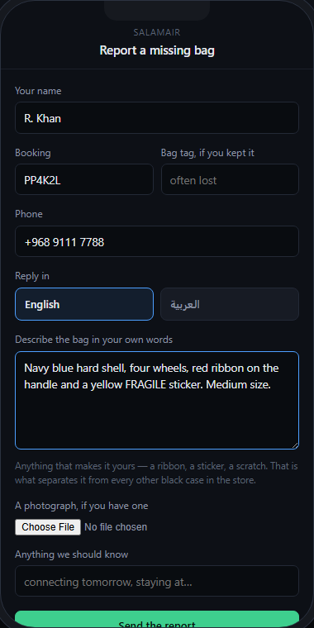
The passenger's form, filled in but not yet sent. Notice there is no dropdown for colour or type: the description is free text, because 'red ribbon on the handle and a yellow FRAGILE sticker' is the part that identifies the bag and no dropdown has that option.
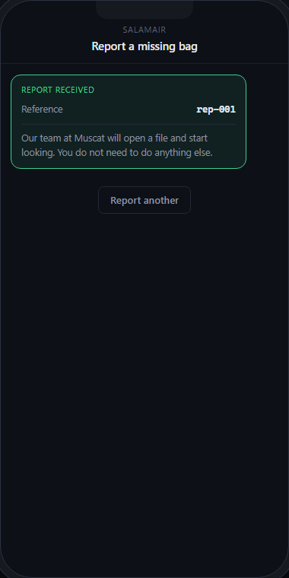
What she sees after sending. It promises nothing except that somebody will look — because at this point nothing has happened.

NO AI IN THIS STAGE — AND WHAT MAKES THAT DELIBERATE
Taking a report is not a judgement, so no model is involved. There is one thing worth noticing about what the code deliberately does not do: it does not summarise, tidy or normalise the passenger's words. Summarising at intake is exactly where the detail that settles a no-tag match — the ribbon, the sticker, the scratch — gets thrown away. The text reaches the agent character for character.

SAY IT IN ONE LINE
The passenger describes the bag in their own words, and those exact words are what the system reasons from — nothing is summarised at the door.

Stage 2 — The desk turns a report into a file
A report is not a baggage file. Creating a file — raising an AHL — is a write into WorldTracer, and this system has no write access, so it cannot do it. The report sits on the desk screen as a card that somebody has to act on. When the desk agent presses Raise the file, a case appears and can be worked.
- Reports queue in their own rail, visibly separate from cases.
- One button, pressed by a person, is what creates the case.
- A report cannot be raised twice, and an unknown report cannot be raised at all.
- The new case is matched against every unclaimed bag held at the station — 7 of them — not against a shortlist somebody prepared.
- The file identifier steps over any photograph already on disk, so a new report can never inherit an earlier passenger's picture.
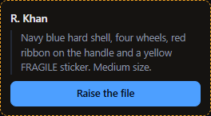
The report as it lands on the desk: a card in the rail marked as waiting for somebody, not a case. Nothing has been created yet.
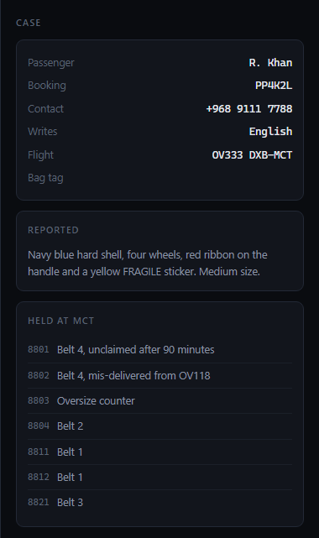
The same report after a person pressed Raise the file. It is now a case with a passenger, a booking reference and a bag description — and 'tag detached', which is why the rest of the flow is necessary.

NO AI IN THIS STAGE — AND WHAT MAKES THAT DELIBERATE
This stage is a person and a button, and it is here on purpose. It is the smallest honest demonstration of the whole Phase A position: the system has read access to the industry record and no write access, so where a write is required a human does it. If the agent could raise files itself, this screen would not exist.

SAY IT IN ONE LINE
Raising a baggage file is a write we do not have, so a person presses the button — the agent works with what a person created.

Stage 3 — It reads the file, and it reads the store
The run begins. The first two things the agent does are the two things a person would do: read what the file actually says, and find out what is physically held at the station. Both are ordinary reads and both return in no measurable time.
- The file, as the agent sees it: station, tag number if any, and the passenger's own text.
- The list of held bags returns references only — no descriptions, because a bag somebody put on a rack does not have a written description.
- Every tool call, its arguments and its output are shown on screen as it happens, so nothing about the reasoning is hidden.
- The agent's own commentary streams alongside, in its words.
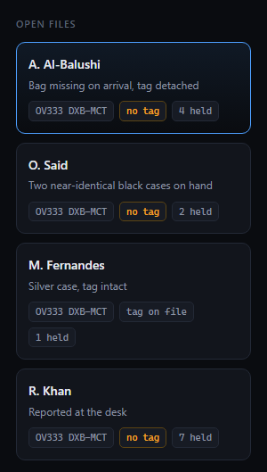
The desk, before anything runs. Files waiting on the left, and the amber 'no tag' chip on A. Al-Balushi — that chip is the reason there is an AI in this system at all. With a tag it would be a join.
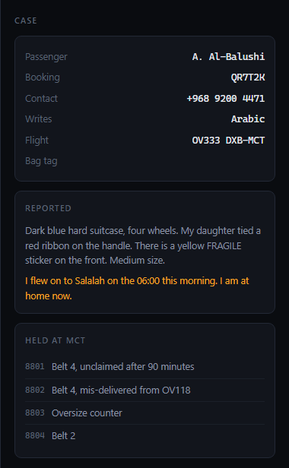
The case as the desk sees it: who she is, her flight, 'Bag tag: detached', her own words, and every bag currently held at Muscat. Everything the agent is about to reason from is on this panel.
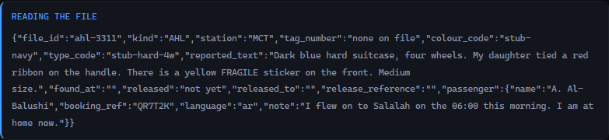
The first read. 'tag_number: none on file' is the whole problem in one field — and note the passenger's reported text is carried through verbatim.
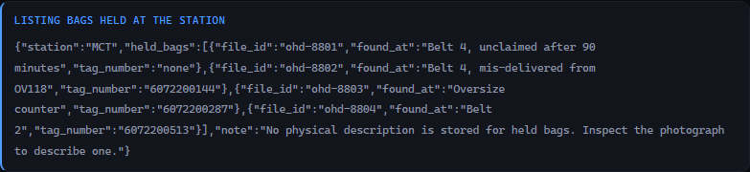
What is held at Muscat: references only. The agent has just learned that there are several candidates and has been told nothing about any of them — which is why the next stage has to look.

NO AI IN THIS STAGE — AND WHAT MAKES THAT DELIBERATE
Both of these are pure code — reading a row and filtering a list — and the control panel measures both at 0.00 seconds mean. Worth saying out loud when somebody assumes an agent means a model call per step: the agent made two tool calls here and used no AI at all.

SAY IT IN ONE LINE
It starts by reading the file and the rack, exactly as a person would, and there is no AI in either step.

Stage 4 — It looks at the photographs
Now the part a query cannot do. The agent opens the passenger's photograph, if there is one, and then each held bag's photograph in turn, and describes what it sees in a fixed set of fields: colour, shell type, wheel count, size, brand lettering, ribbon, stickers, and — the field that does the work — individual marks. It is not asked whether the bags match yet. It is asked what is in front of it.
- One call per photograph, so each description is made without knowing what the others said.
- A fixed answer shape, including a confidence figure and a flag for whether a bag tag is visible.
- A list field specifically for scuffs, tears and repairs — the things that separate one bag from another of the same model.
- Attributes render beside the photograph on screen, so a person can check the reading against the image.
- The agent chooses how many photographs to open. On the case in this walkthrough it opened five; on a case where the tag was still attached it opened none.
One photograph, read into fields. The line to look at is the distinguishing marks: a pale scuff beside the sticker. Colour and shape narrow the field; a scuff is what identifies an individual object.

WHERE THE AI IS — AND WHAT CHECKS IT
The model call: inspect_photograph sends one image and asks for a description. Measured 5.98 seconds mean across 21 calls on 3 September 2026.
What checks it — three things, and none of them is trust. First, the answer is schema-bound: it must return every field, shell must be one of hard, soft or unclear, and wheels must be an integer with zero meaning none visible — so it cannot answer with a paragraph of hedging. Second, the photograph is on the screen beside the description, so a person can disagree with it in a second. Third, and most importantly, this stage does not decide anything. It produces evidence. The decision is the next stage, which is a separate call that has to look at both images itself.

SAY IT IN ONE LINE
It looks at each bag and writes down what it sees — including the individual scuffs, which are what separate one suitcase from another of the same model.

Stage 5 — It compares the two that matter
Having described everything, the agent puts the passenger's photograph and the most likely held bag side by side in a single call and asks the question that resolves the case: are these the same physical bag? The answer must be one of three words, and it must come with the features that agree, the features that conflict, and two or three sentences a desk agent could read aloud.
- Two images in one call, so the judgement is made on both at once rather than by comparing two written descriptions.
- A verdict restricted to same bag, different bag, or cannot tell.
- Agreements and conflicts listed separately, with the rule stated in the call itself that one hard conflict outweighs many agreements.
- A confidence figure.
- Written reasoning, in language a person can repeat to a passenger.
- Both photographs shown on screen beneath the verdict, so the reasoning can be checked against the evidence.
The comparison that resolves the case: same bag, 86 per cent, no conflicts. Read the reasoning — the decisive item is not the colour, it is 'the same pale scratch mark appears to the right of the sticker at matching height in both images, which is an individual wear feature rather than a model trait.'
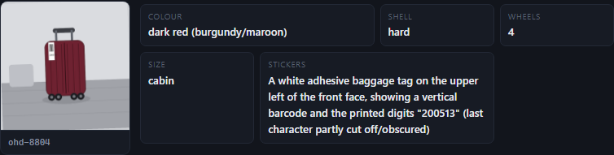
The two photographs the verdict was made from, reported and held side by side. This is what makes the reasoning checkable: look for the pale scuff to the right of the yellow sticker in both.
This is the moment worth slowing down for in front of an audience, because of what is sitting next to her bag in the store. There is another hard-shell case there with the same red ribbon on the handle. Colour and ribbon alone would have picked the wrong one. On this run the agent excluded it and said why, in its own commentary:
Match confirmed on individual features, not just colour. The other three are excluded (black TUMI large, navy soft-side 2-wheel, burgundy cabin).
Claude Opus 5, case-3311, run of 3 September 2026, recorded in run history

WHERE THE AI IS — AND WHAT CHECKS IT
The model call: compare_photographs sends both images and asks for a verdict. It runs at the highest reasoning effort of any call in the system, and was measured at 8.76 seconds mean across 4 calls on 3 September 2026.
What checks it. The verdict is a closed list of three values — so 'probably hers' is not a thing it can say, and cannot_tell is a first-class answer rather than a failure. The call is required to produce a conflicts list as well as an agreements list, which is what stops a pile of similarities standing in for proof. Both photographs are rendered on screen underneath, so the reasoning is falsifiable by looking. And nothing follows from this verdict on its own: every action it leads to stops for a person in stage 6 and stage 7.

SAY IT IN ONE LINE
It rejected the near-miss — another case with the same red ribbon — and told us the scratch mark was what settled it, which is a reason you can check against the picture.

Stage 6 — It writes to the passenger, in both languages — and stops
The bag is identified. The next thing that should happen is that the passenger is told, so the agent drafts the message: what was found, what is being proposed, what has not happened yet, and what she can do about it. It writes it in English and in Arabic, and it adds one line explaining why it is worded the way it is. Then the run stops. The message is on the desk screen as a proposal with an Approve button, and the passenger's phone is empty.
- Both languages produced in a single call, so they say the same thing.
- A note on tone, which is where the choices it made are visible.
- The message states plainly that the bag has not moved yet.
- It offers her the alternative — collection at Muscat — rather than presenting the decision as final.
- The run halts. Its status becomes awaiting approval and it will stay there indefinitely.
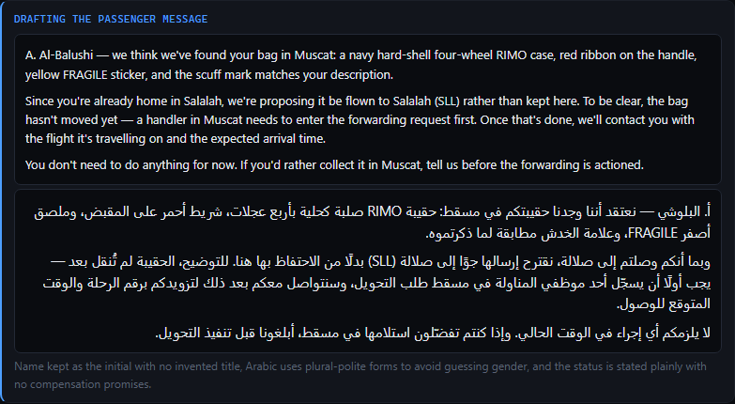
The drafted message, both languages side by side. Read the tone note at the bottom: 'Arabic uses plural-polite forms to avoid guessing gender' — a choice about a person, made explicit rather than buried.
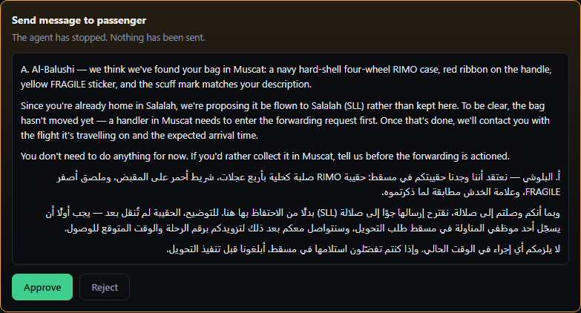
The same message as an approval card. Until this button is pressed the message exists only here.
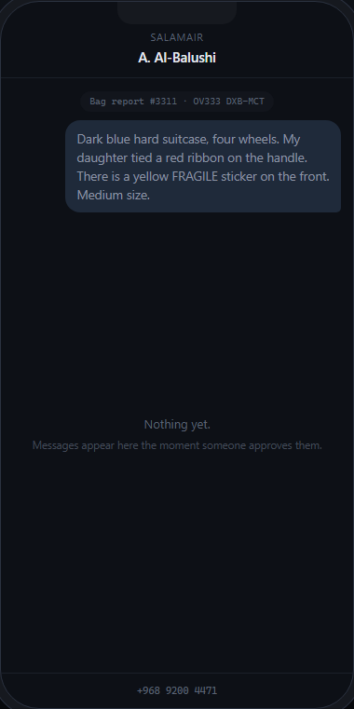
The passenger's phone at that exact moment — captured before the click. This is the screenshot to show anybody who asks whether the system can contact passengers on its own.
What it wrote, unedited, on the run this walkthrough is taken from:
A. Al-Balushi — we think we've found your bag in Muscat: a navy hard-shell four-wheel RIMO case, red ribbon on the handle, yellow FRAGILE sticker, and the scuff mark matches your description. Since you're already home in Salalah, we're proposing it be flown to Salalah (SLL) rather than kept here. To be clear, the bag hasn't moved yet — a handler in Muscat needs to enter the forwarding request first. […] If you'd rather collect it in Muscat, tell us before the forwarding is actioned.
Name kept as the initial with no invented title, Arabic uses plural-polite forms to avoid guessing gender, and the status is stated plainly with no compensation promises.
its own note on why the message is worded that way

WHERE THE AI IS — AND WHAT CHECKS IT
The model call: draft_passenger_message writes both languages and the tone note. Measured 16.00 seconds mean across 3 calls on 3 September 2026 — the slowest call in the system, because it is writing prose in two languages rather than filling in fields.
What checks it. The strongest check is not a technical one: a person reads the message before anybody receives it, because notify_passenger is an act tool and the loop refuses to execute it without an approval carrying that exact call's id. The schema forces all three fields, so it cannot quietly skip the Arabic. And the tone note is itself a check — it makes the model state the assumptions it made about the reader, which is how you catch it inventing a title or guessing somebody's gender.

SAY IT IN ONE LINE
It drafts the message in both languages and then stops dead — the passenger's phone stays empty until a person at the desk presses Approve.

Stage 7 — It chooses what should happen to the bag — and stops again
This is the stage that makes it an agent rather than a workflow. Two tools are available and nothing tells it which to use: it can prepare a forwarding instruction, sending the bag on to where the passenger is, or a collection instruction, holding it at the baggage service office for her to pick up. Which is right depends entirely on where the passenger actually is, which is in a sentence she typed. It reads that sentence and picks. Then it stops for a second, separate approval.
- Two tools, both offered, no rule choosing between them.
- The choice is made from the passenger's own note, not from a field.
- A second approval, distinct from the message approval — approving one does not approve the other.
- The instruction carries a reference so the paperwork can be traced.
- It attempts the write to WorldTracer, is refused, and carries the refusal in its output.
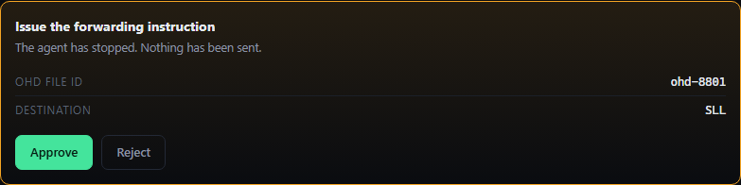
The second stop, on the forwarding instruction. Notice the word 'forwarding' — it had a choice and this is the one it made.
On the three demonstration cases it chooses differently each time, and the reason is always the passenger rather than the bag:
Case | What the agent read | What it chose
A. Al-Balushi | 'I flew on to Salalah on the 06:00 this morning. I am at home now.' | Forward to Salalah
M. Fernandes | Muscat is her own arrival airport — she is in the building the bag is in | Hold for collection
R. Khan (reported live) | The file says nothing about where she is, so it asked her, and she said she is in Muscat until Thursday | Hold for collection

WORTH SAYING OUT LOUD
Nothing told it to do that. Both tools were available on all three cases, there is no rule in the code that mentions Salalah or arrival airports, and the deciding fact was in a sentence a passenger typed. This is the whole argument for giving a model judgement rather than a workflow: a workflow would have had to pick a default, and either default is wrong for two passengers out of three.

WHERE THE AI IS — AND WHAT CHECKS IT
No new model call happens here — this is the loop's own model call, the one that chooses which tool to use next. That call runs at high reasoning effort on every turn and is the only place in the system where the agent decides anything about sequence.
What checks it. Both tools are act tools, so whichever it picks halts the run for a person — and the approval card names which one it picked, so choosing wrongly is visible before it costs anything. The instruction itself is built by code, not written by the model: the model supplies the destination, and build_forward_instruction() produces the steps. And there is a ceiling of 14 turns on the loop, so a model that cannot decide stops rather than circling.

SAY IT IN ONE LINE
Two tools were on the table and nothing chose between them — it read where the passenger said she was and picked, then stopped for a second signature.

Stage 8 — The handover — what a handler actually types
What appears after the approval is not a booking confirmation, because the system did not book anything. It is a numbered list of the entries a handler makes, each with what that entry should return. This is the shape of the whole Phase A position: we have read access to the industry system and no write access, so the agent works out the answer and hands over exactly what to type.
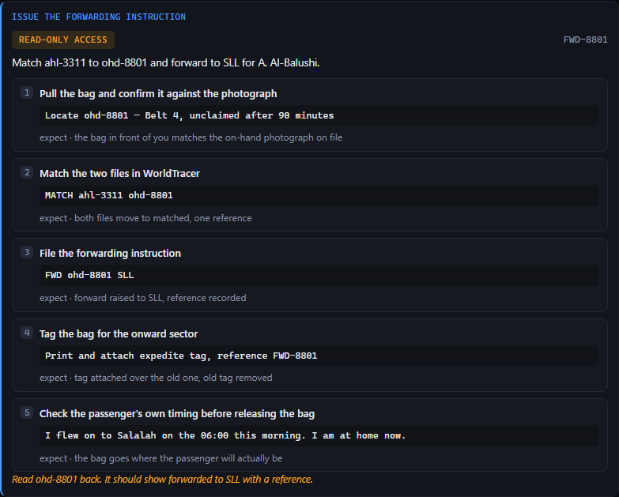
Five steps, in order, each with the literal entry beside it. Step 1 is the physical check against the photograph — the one thing no software can do, put first rather than last.
What it produced, verbatim:
1 | Pull the bag and confirm it against the photograph | Locate ohd-8801 — Belt 4, unclaimed after 90 minutes
2 | Match the two files in WorldTracer | MATCH ahl-3311 ohd-8801
3 | File the forwarding instruction | FWD ohd-8801 SLL
4 | Tag the bag for the onward sector | Print and attach expedite tag, reference FWD-8801
5 | Check the passenger's own timing before releasing the bag | I flew on to Salalah on the 06:00 this morning. I am at home now.

Step 5 is worth a sentence of its own. Nothing asked for it. The agent carried the passenger's own words down into the handler's checklist so that the person holding the bag can see the fact the routing decision rests on, and stop if it looks wrong.

NO AI IN THIS STAGE — AND WHAT MAKES THAT DELIBERATE
The steps are generated by build_forward_instruction() — ordinary code, measured at 0.00 seconds, and covered by tests. This is deliberate and it is the most conservative choice in the product. Instructions that a person will execute against a live industry system are exactly what you do not want a language model improvising, because a plausible-looking wrong entry is worse than no entry. The model decides what should happen; the code decides how it is written down.

SAY IT IN ONE LINE
It does not pretend to file anything — it hands a person the five entries to make and what each one should come back with.

Stage 9 — It reads the record back — and reports that nothing happened
The agent then does something unusual for a system of this kind: it checks its own work by looking, and it reports failure. It re-reads the baggage file and finds no forward on it, because at this moment no handler has typed anything. So it says so, on screen and in its closing summary, rather than reporting the success of an instruction it issued.

The read-back: 'not done — the file shows nothing yet, the handler has not done it.' The system's own verdict on its own work, two seconds after issuing the instruction.
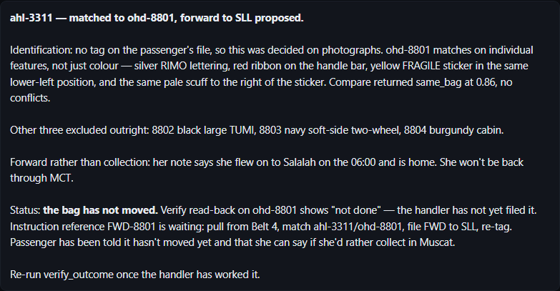
The closing summary. The heading a reader will remember is in the middle: 'the bag has not moved.'
The line to read aloud, exactly as it appeared:
Status: the bag has not moved. Verify read-back on ohd-8801 shows "not done" — the handler has not yet filed it. Instruction reference FWD-8801 is waiting: pull from Belt 4, match ahl-3311/ohd-8801, file FWD to SLL, re-tag. […] Re-run verify_outcome once the handler has worked it.
Claude Opus 5, case-3311, run of 3 September 2026

NO AI IN THIS STAGE — AND WHAT MAKES THAT DELIBERATE
The read-back is code: it re-reads the row and compares it with what was asked for. There is no model call and no opinion in it, which is the point — the check on the AI's work is not itself an AI. The model's contribution here is only to have called the tool at all, and then to have reported the answer honestly in its summary instead of describing its own instruction as a result.

SAY IT IN ONE LINE
It issued the instruction, then looked at the record and told us the bag had not moved — a system that will not claim something happened until it has seen it.

Stage 10 — The handler does the work, and the read-back changes
The instruction is waiting on a third screen, the handler's. It is the same five steps, marked as waiting on them. The handler does the physical work, presses 'I have filed it', and that button is the only write in the entire demonstration — pressed by a person. Run the case again and the read-back now answers differently.
- A screen for the person who touches the bag, because the desk cannot file the forward and somebody has to know that they must.
- The same reference, so the two screens are talking about the same job.
- One button, and it is the only write.
- On the next run, the read-back returns confirmed and quotes the reference off the file.
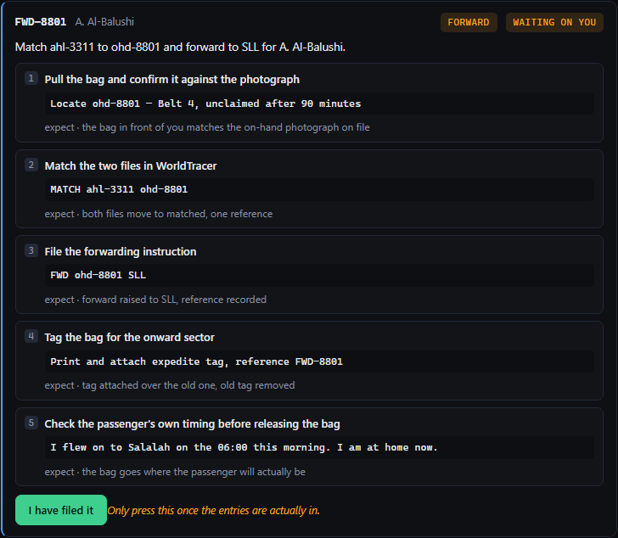
The handler's screen: the job, the five steps, and 'waiting on you'.
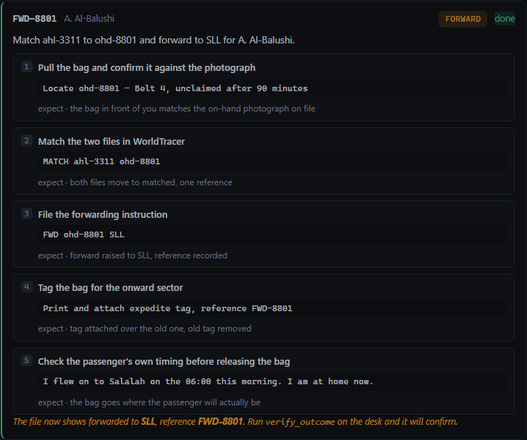
After the button. This click is the only write in the demonstration, and a person made it.

The same read-back tool, on a later run, now answering 'confirmed — file shows forwarded to SLL, reference FWD-8801'. Nothing told the agent the work was done; it found out by reading.
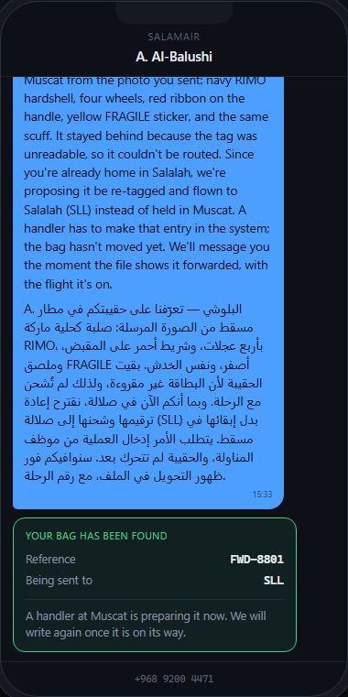
What the passenger ended up with, in her own language.

THE PHASE A ARGUMENT, IN NINETY SECONDS
The agent decided. A person acted. The agent found out by looking rather than by being told.
That is the whole case for deploying this before the write access exists. The airline gets the judgement, the reasoning and an audit trail that does not exist today, and the vendor has granted nothing. And a system that refuses to tell you a bag moved until it has checked is the reason to believe the rest of what it says.

NO AI IN THIS STAGE — AND WHAT MAKES THAT DELIBERATE
There is no model call anywhere in this stage. The handler's screen, the button, the write to the record and the read-back that follows are all ordinary code. That is worth saying because this is the stage that closes the loop: the evidence that the agent's work was real is produced entirely without the agent. The only contribution the model makes here is to have called the read-back tool on the next run, and then to have reported what it said.

SAY IT IN ONE LINE
A person filed it, and the agent confirmed it by re-reading the record — the only write in the demonstration is a human pressing a button.

Stage 11 — When the file does not say, it asks the passenger
Stage 7 turns on knowing where the passenger is. Sometimes the file does not say. A workflow would pick a default; this agent asks. It stops the run, puts a question on the passenger's phone with a reply box, and waits — and this pause is different in kind from every other stop in the system, because nobody at the desk can end it. It is not an approval. The only person who can unblock it is somebody who does not work for the airline.
- A distinct pause state — awaiting reply, not awaiting approval.
- The question is asked in the passenger's own language, and it says why it is being asked.
- A reply box on the phone screen; the answer goes back into the run and it picks up where it stopped.
- The desk screen shows that it is waiting and that nothing there can end it.
- A Stop waiting button, for when nobody answers — the agent then decides anyway and says in its summary that it decided without them. A demonstration that hangs because somebody put a phone down is not a demonstration.
The desk, parked. 'Asked, and waiting for her to answer' — and the note that nothing here can end it.
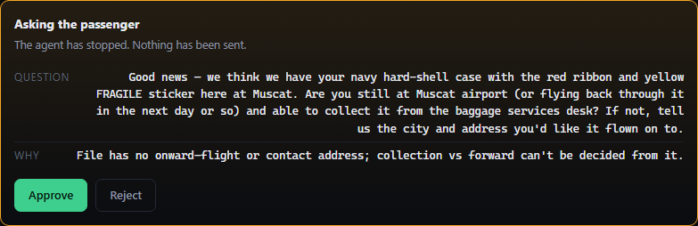
Before she sees anything: the question itself waiting for a signature. Asking a passenger something is an `act` tool like any other, so nobody is contacted on the model's initiative alone.
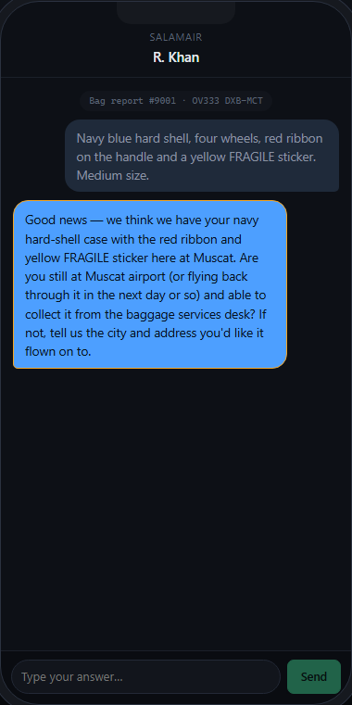
The question as she receives it, with a reply box. Notice it explains why it is asking rather than just asking.
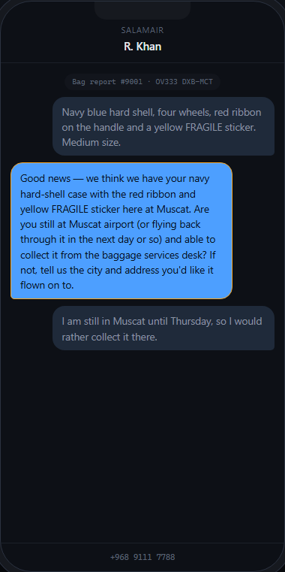
Her answer, in her own words, going back into a run that was already in progress.
What it asked, on the live report in this walkthrough:
Good news — we think we have your navy hard-shell case with the red ribbon and yellow FRAGILE sticker here at Muscat. Are you still at Muscat airport (or flying back through it in the next day or so) and able to collect it from the baggage services desk? If not, tell us the city and address you'd like it flown on to.
Claude Opus 5, case-9001, run of 3 September 2026
She answered that she is in Muscat until Thursday and would rather collect it, and the agent held the bag instead of flying it. Its reasoning for asking rather than guessing, in its own words: “I asked the passenger rather than assume.”
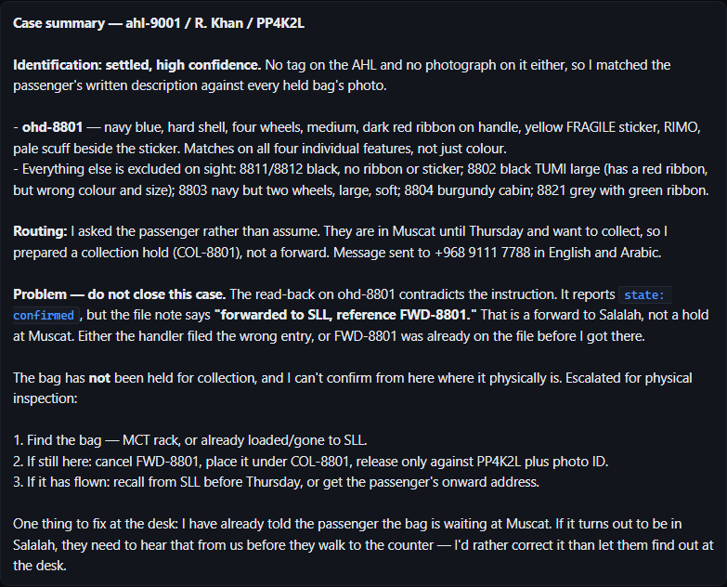
How that run ended. It records that it asked rather than assumed, and what she said — so the reason for holding the bag rather than flying it is on the file.

WHERE THE AI IS — AND WHAT CHECKS IT
No separate model call. Asking is a decision the loop's own model call makes, and ask_passenger is an act tool, so the question itself is approved by the desk before the passenger ever sees it. Nobody is contacted on the model's initiative alone.
What checks it. Two things, and the second is the interesting one. The approval gate means a person reads the question first. And the pause is structurally not an approval — the run's status is awaiting_reply, a state the desk cannot clear by clicking, so the system cannot quietly substitute a staff member's guess for the passenger's answer. The Stop waiting escape hatch exists, and when it is used the agent says in its summary that it decided without them.

SAY IT IN ONE LINE
When the file did not say where she was, it did not guess and it did not ask a colleague — it asked her, and waited.

Stage 12 — When it cannot tell, it refuses
The last stage is the one that makes the rest credible. O. Said reports a plain black hard case with, in his words, 'no markings that I recall'. Two plain black hard cases are held at the station. The agent inspects all three photographs, compares twice, and returns cannot tell both times — and then does not escalate immediately either. It works out that contents are the only remaining discriminator, asks the passenger to name what is packed inside, and hands the answer to a handler with an instruction to open both cases.
- Two comparisons rather than one, because there were two candidates.
- Cannot tell returned at 70 per cent and then at 35 per cent confidence, with zero conflicts listed — nothing separated the bags either way.
- No forwarding or collection instruction was prepared at all. On this case it never reaches stage 7.
- No message was sent to the passenger promising anything.
- It named the discriminator it did not have, and asked for it.
- It escalated to a human handler with the contents to check against.
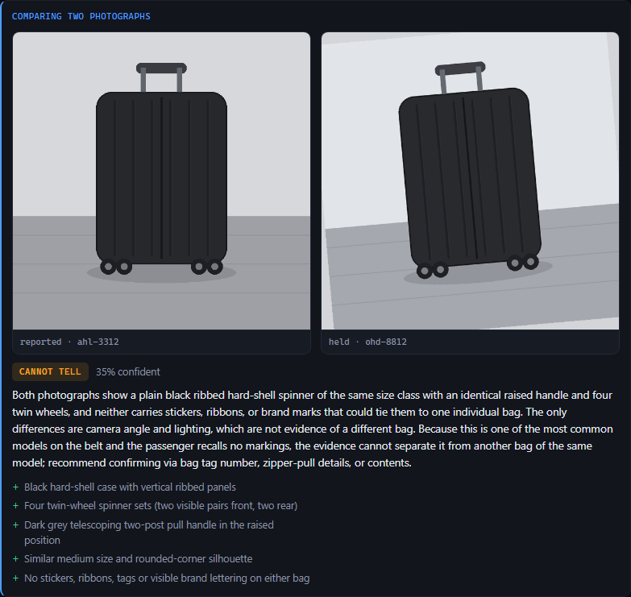
The refusal. Zero conflicts and zero agreements that mean anything: 'neither carries stickers, ribbons, or brand marks that could tie them to one individual bag.' The verdict is 'cannot tell' at 35 per cent.
Its own reasoning, verbatim:
Both photographs show a plain black ribbed hard-shell spinner of the same size class with an identical raised handle and four twin wheels, and neither carries stickers, ribbons, or brand marks that could tie them to one individual bag. […] Because this is one of the most common models on the belt and the passenger recalls no markings, the evidence cannot separate it from another bag of the same model; recommend confirming via bag tag number, zipper-pull details, or contents.
compare_photographs, case-3312, run of 3 September 2026
Photographs can't separate the two — both are the same common ribbed black spinner, no ribbon, sticker, brand or scuff on any of the three images. I won't guess between them. The tie-breaker has to be contents, and only the owner can supply that.
the agent's own commentary on the same run
Rather than stopping at 'I cannot tell', it works out what would settle it and asks for that. Note it explains to the passenger that a handler will open both cases.
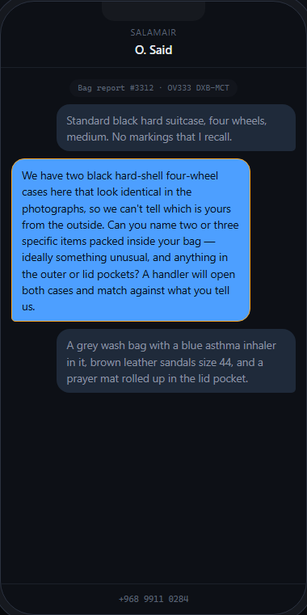
The answer that makes the case resolvable by a person.
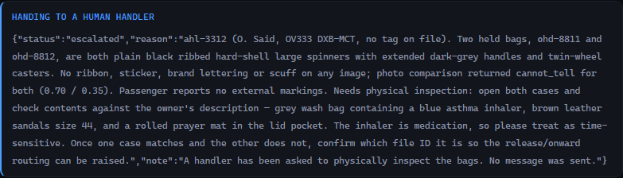
The escalation. Read the second half — it noticed on its own that one of the items named is medication.
The escalation it wrote, verbatim and unedited:
Two held bags, ohd-8811 and ohd-8812, are both plain black ribbed hard-shell large spinners with extended dark-grey handles and twin-wheel casters. No ribbon, sticker, brand lettering or scuff on any image; photo comparison returned cannot_tell for both (0.70 / 0.35). Passenger reports no external markings. Needs physical inspection: open both cases and check contents against the owner's description — grey wash bag containing a blue asthma inhaler, brown leather sandals size 44, and a rolled prayer mat in the lid pocket. The inhaler is medication, so please treat as time-sensitive. Once one case matches and the other does not, confirm which file ID it is so the release/onward routing can be raised.
escalate_to_human, case-3312, run of 3 September 2026
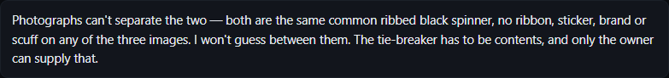
How the case that could not be resolved was closed out: no match claimed, no instruction issued, and a handler holding a specific thing to check.
Nothing in the system mentions medication, urgency or inhalers. It read a list of somebody's belongings, recognised that one of them was a medical item, and changed the priority it handed to a person. That is worth pointing at, and it is also worth being careful about: it is evidence of what the model can notice, not a guarantee that it will notice next time. Nothing in the product enforces it.

WHERE THE AI IS — AND WHAT CHECKS IT
Two model calls, and both of them declining. compare_photographs ran twice and returned cannot_tell twice.
What checks it. The check here is that refusing is a legal answer. The verdict enum contains cannot_tell alongside the two useful answers, so the model is never in a position where the only expressible outputs are confident ones. And escalate_to_human is a read tool that produces a note and reaches nobody outside the building — so escalating costs nothing and cannot go wrong, while guessing would have sent a stranger's belongings to somebody's home.
One measured fact worth having: on this run the refusal cost $0.22 by the point it escalated. Being sure it cannot tell is not a cheap outcome — it costs roughly what being sure it can costs, which means nothing in the pricing pushes it towards a guess.

SAY IT IN ONE LINE
It compared twice, said it could not tell, refused to guess between two identical black cases, and asked for the one thing that would settle it — a system that knows when it cannot tell is what makes the rest of it worth believing.

6 The complete AI map
This is every place a language model is called. There are four, and there are 11 tools, so most of what the system does is not AI at all. Speeds were measured from the control panel's own telemetry on 3 September 2026; the call counts are the calls made that afternoon.
Capability | Which stage | Measured speed | What checks it
The loop's own call — chooses what to do next, and writes the commentary and the closing summary | Every stage. Runs once per turn. | not separately timed  (the run as a whole: 106–162 s) | It can only choose from the tools it is offered, and any `act` tool it chooses halts the run for a person. A ceiling of 14 turns stops it circling.
Perception — describe one bag photograph into fields | Stage 4 | 5.98 s mean  21 calls | Schema-bound: every field required, `shell` and `size` from fixed lists, `wheels` an integer. The photograph is on screen beside the description. It decides nothing.
Comparison — judge whether two photographs show the same physical bag | Stages 5 and 12 | 8.76 s mean  4 calls | Verdict restricted to same bag / different bag / cannot tell. Must list conflicts as well as agreements. Both images rendered beneath the verdict. Everything downstream of it stops for a person.
Drafting — write the passenger's message in English and Arabic | Stage 6 | 16.00 s mean  3 calls | A person reads it before anybody receives it, because `notify_passenger` is an `act` tool. Both languages required by the schema. It must also state why it worded it that way.

Deliberately not AI
Everything in this list could have been a model call and is not. Each one is measured at 0.00 seconds mean on the control panel, because there is no network call in it.
- Reading the baggage file and listing what is held. Both are database reads with a right answer.
- Building the handover instruction. The five steps a handler types are generated by code and covered by tests. A plausible-looking wrong entry against a live industry system is worse than no entry at all.
- The read-back. The check on the AI's work is deliberately not itself an AI. It re-reads the row and compares.
- The approval gate. Whether a tool needs a person is declared on the tool and enforced in the loop. No model is consulted about whether something is safe.
- File numbering. It steps over anything already on disk, so a new report cannot inherit an earlier passenger's photograph.
- Escalating. Producing the note is code; deciding to escalate is the loop's judgement.
- Cost and token accounting. Counted, not estimated, per run.

THE LINE THAT ANSWERS 'HOW MUCH OF THIS IS ACTUALLY AI?'
Three of the eleven tools call a model, and they are the three that involve looking at a photograph or writing to a person. The other eight are ordinary code and take no measurable time. That division is the design: the AI is used where the problem is evidence and judgement, and nowhere else.

7 The safety rails
Seven rails. For each one, what makes it true rather than intended, and — the part usually left out — what you would actually observe if it stopped being true. A rail nobody can check is not a rail.

1. The agent cannot write to the baggage record
How it is enforced. The file store reports can_write = False and file_forward() raises AccessDenied unconditionally. Every resolution attempts the write, is refused, and carries the refusal text in its own tool output on screen. There is no setting that changes this.
How you would see it fail. The forwarding or collection card's output would show an empty refused field. On every run it should read: “no write access to WorldTracer. Forwarding ohd-8801 to SLL must be filed by a handler.” If that sentence is missing, something has been granted write access.

2. Nothing reaches a passenger or a handler without a click
How it is enforced. Four of the eleven tools are marked act: messaging the passenger, asking the passenger a question, and the two handover instructions. The loop refuses to execute an act tool unless a person has approved that specific call by its own id, and sets the run's status to awaiting_approval instead. Approving one does not approve the next.
How you would see it fail. A message would appear on the passenger screen without an approval card having been clicked for it. The run history records every tool call, so a notify_passenger in a record with no corresponding approval is the evidence.

3. Refusing is a first-class answer
How it is enforced. The comparison call's verdict is a closed list: same_bag, different_bag, cannot_tell. The model is never in a position where the only expressible answers are confident ones, and escalating is a read-only tool that costs nothing and reaches nobody.
How you would see it fail. A verdict badge showing anything outside those three, or a case with two visually identical bags resolving to a match. The observable test is the one in section 5, stage 12: run O. Said's case and it must refuse.

4. The agent verifies by reading, not by assuming
How it is enforced. The read-back is code, not a model call: it re-reads the row and reports what the file now says. Nothing tells the agent that a handler has acted.
How you would see it fail. A closing summary claiming a bag has been forwarded while the handler screen still says 'waiting on you'. This rail has already caught a real defect. On 3 September 2026, two files were matched to the same held bag: one had been forwarded to Salalah and a second passenger's collection hold was prepared for it minutes later. The read-back found the contradiction and the agent refused to close the case. Its own words are in section 12. The underlying cause — a released bag was still being listed as held — was fixed the same day and is now covered by two tests.

5. A pause for a passenger cannot be cleared by staff
How it is enforced. When the agent asks the passenger something the run enters awaiting_reply, which is a different state from an approval and cannot be satisfied by any button on the desk screen. Only a reply from the passenger, or the explicit Stop waiting escape, moves it on — and when Stop waiting is used the agent says in its summary that it decided without them.
How you would see it fail. A run that was waiting for a passenger continuing without an answer and without saying so. The desk screen states, in words, that nothing there can end the pause.

6. The run is bounded
How it is enforced. A ceiling of 14 turns per run, set in the control settings. Cost and tokens are counted per run rather than estimated, and each run's own spend is recorded as a delta rather than the session total.
How you would see it fail. A run that never ends, or a recorded cost that rises when you open the record rather than staying fixed. The longest run measured on 3 September 2026 used 10 turns of the 14.

7. Every approval carries a name
How it is enforced. The console sends who is acting on every request, and approve() records a signature — person, role, time — on the run and on the act tool call it released. The API refuses an action the selected role may not take, in a sentence that names them: “S. Al-Amri (Ramp handler, MCT) cannot change the agent's settings.” One shared password gets you in; which person you then claim to be is not checked. The enforcement and the stamp are not mocked.
How you would see it fail. A run record with an approval and no actor on it, or an act tool call in the record without an approved_by. An unsigned approval from the terminal is recorded as Unattributed rather than dropped, so the absence is visible.
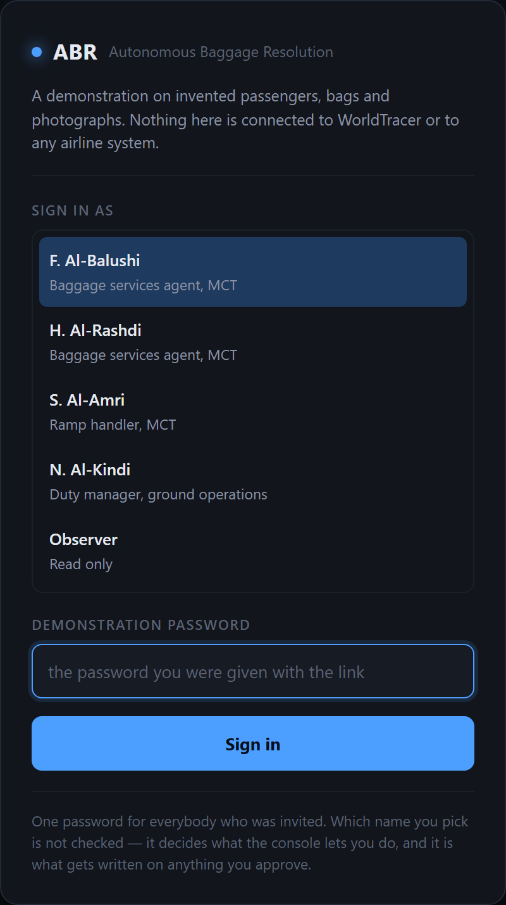
The door. One shared password, handed out with the link. Until it is given, nothing is readable — not the cases, not the photographs, not the run history. Which of the five people you then act as is not checked, and the page says so rather than implying an account system that is not there.
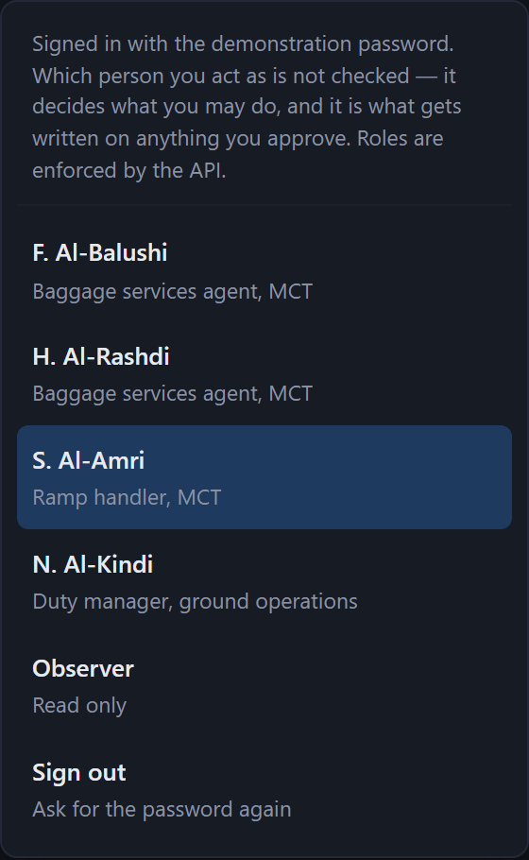
The sign-in, on every screen. One password to get in, then five named people to act as. Open the desk as one and the handler screen as another and the separation stops being a matter of which tab you are looking at.

THE ONE RAIL WITH A SWITCH ON IT — SAY THIS BEFORE SOMEBODY FINDS IT
Rail 2 has an off switch. The control panel has Approve automatically, which exists so a run can be rehearsed end to end without a person clicking a dozen times. While it is on, no tool stops for anybody. It is off by default and it is visible on the screen. Before any real pilot it should be removed or put behind an authorisation, and that is on the list in section 11. Rails 1, 3, 4, 5, 6 and 7 have no equivalent.
Two of the other rails are also weaker than they look, and it is better to say so. Rail 3 depends on the model choosing to use the closed list honestly — the schema stops it inventing a fourth verdict, but nothing forces it to pick cannot-tell when it should. Rail 4 depends on the agent choosing to call the read-back at all; it did so on every run measured, but that is an observation, not a guarantee.

Where you can see the rails on screen
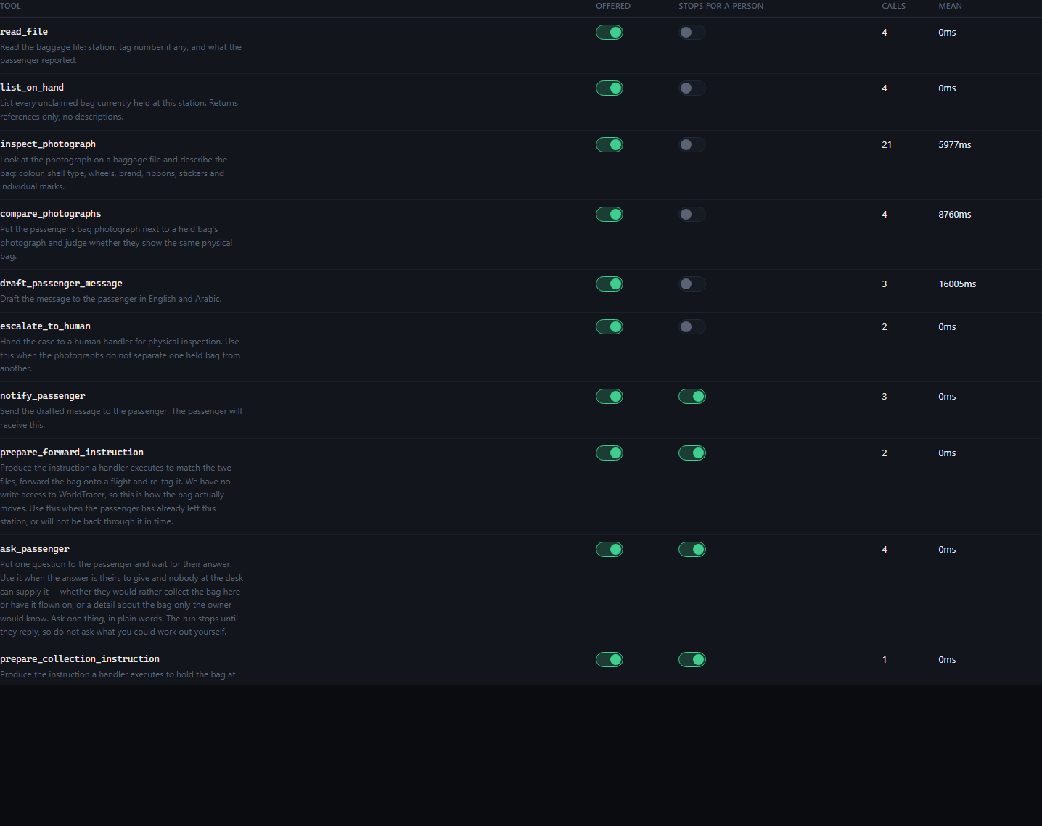
The control panel's tool table: every tool, whether it stops for a person, and whether it is being offered to the model at all. This is the rail list as the product sees it, not as a document describes it.
The model selector. Switching to Haiku 4.5 and re-running a case is the fastest way to show what happens when the model is not good enough for the job.

8 What is real and what is a stand-in
Anybody who is going to explain this system needs to know precisely which parts would survive being pointed at a live operation and which are scaffolding. This is that list. It is in the body of the document rather than in a footnote because getting caught out on it in a room is worse than the limitation itself.
 | What | Detail
REAL | The model calls | Live calls to Claude Opus 5 over the Anthropic API, billed. Nothing is recorded or replayed. Every quotation in this document is output from a call made on 3 September 2026.
REAL | The agent loop and the approval gate | The halt-for-a-person behaviour, the `awaiting_reply` pause, the turn ceiling, the per-run cost accounting and the run history are all production-shaped code with tests.
REAL | The refusal to write | `can_write = False` and the `AccessDenied` raise are the real mechanism, not a stub standing in for one. This is what Phase A would look like against a live WorldTracer.
REAL | The six console screens | The desk, the passenger's phone, the handler's queue, the report form, the control panel and the run history are the product, built and served, not mock-ups.
SYNTHETIC | Every passenger, bag, tag, flight and photograph | 10 baggage files, 7 held at Muscat, 3 written cases, generated by `uv run abr data generate`. The photographs are rendered, not photographs of real bags. No real passenger, booking, bag or tag appears anywhere.
SANDBOX | The record of truth | There is no WorldTracer and no passenger service system. The 'industry record' the agent reads and reads back is a CSV file on disk. The read-back mechanism is real; what it reads is not.
SANDBOX | Messaging | Nothing is sent. Approving a message renders it on a phone-shaped screen in another browser tab. No SMS, WhatsApp or voice channel is connected.
MOCK | Identity | One shared password opens the console; after that you pick a name from a roster of five and anybody can claim to be anybody. What is not mocked: the API refuses the desk when it tries to file the handler's confirmation, and every approval is stamped with a name, a role and a time on the run record. Authentication is pretend; authorisation and attribution are enforced.
BY HAND | The three parties | Passenger, desk agent and handler are three browser tabs on one machine, driven by whoever is presenting. The separation of who can do what is real; the people are not.
BY HAND | The handler's confirmation | 'I have filed it' is a button that writes to the local CSV. In a pilot it would be a handler making entries in WorldTracer and the read-back finding them there.

CANDID — NOT FOR AN AUDIENCE
Read this, then do not say it in the room. It is not dishonest, but it is the material an unfriendly question would be built from, and you should know it before somebody else finds it.
1. The demonstration set is constructed, not sampled. The near-miss in stage 5 — a second hard case with the same red ribbon — is there on purpose, so that colour alone picks the wrong bag and only an individual feature separates them. The two identical black cases in stage 12 are there on purpose so that the system has to refuse. The three written cases were chosen to have three different right answers. This is a set designed to exercise the interesting paths, and it tells you nothing about how often the system would be right on a real week of Muscat arrivals. Nobody has measured that, and this document must not imply otherwise.
2. The walkthrough in section 5 is stitched from three runs. Each stage names its run and every stage happened, but no single case produces all twelve stages. Do not describe it as one continuous run.
3. Two real defects were found by this document's own capture session, on 3 September 2026. A report submitted with no photograph inherited a photograph left on disk by an earlier session under a reused file id — one passenger's picture on another passenger's bag. And a bag already forwarded to Salalah was still listed as held at Muscat, so a second passenger was matched to it. Both are fixed and both now have tests. Mention them if asked how faults are found, because the honest answer is a good one — the read-back caught the second one by itself. Do not volunteer them as an opening.
4. The stage screenshots predate the identity layer and the sign-in. They were captured on 3 September 2026. Approval cards now carry a “Signing as …” line and the run history a “who signed it” section, neither of which appears in section 5's pictures, and every one of those screens now sits behind the password. The two sign-in figures in section 7 are current; the rest are a few days old, because recapturing them costs real model calls and was not done for a line of text.
5. Run history can lose the end of a resumed run. A run is driven by the browser's open connection. If the screen is closed while a run is parked waiting for a passenger, the recorded record stops at the pause even though the work continued. This happened while capturing stage 12, which is why its figures are quoted from the live control panel rather than from a completed record.

Every screenshot in this document that shows synthetic data shows it with the labels the product itself displays — file identifiers, 'tag detached', the station code. Nothing has been relabelled to look more real than it is, and the footer on every page of this document says so.

9 The numbers, as measured

IF THE PRODUCT AND THIS DOCUMENT DISAGREE, THE PRODUCT IS RIGHT
Every figure below was read off the running system or a recorded run on the date given, and each one lives in a named constant at the top of the generator that produces this document, so a stale number is visible as one. Nothing here is estimated, rounded from a similar run, or remembered. If you open the product and it says something different, the product is right and this page is out of date — open /runs and read the figure off the record.

The system, counted
Tools the agent has | 11 (7 read, 4 that stop for a person) | 3 September 2026
Of those, tools that call a model | 3 | 3 September 2026
Console screens | 6 | 3 September 2026
Automated tests passing | 131 | 8 September 2026
Baggage files in the synthetic world | 10 | 3 September 2026
Unclaimed bags held at Muscat | 7 | 3 September 2026
Written demonstration cases | 3 | 3 September 2026
Turn ceiling per run | 14 | 3 September 2026
Write operations the agent can perform | 0 | 3 September 2026

The runs this document is built from
4 runs on the afternoon of 3 September 2026, all on Claude Opus 5, all with every approval clicked by hand. Every screenshot and every quotation in this document comes from these.
Case | What it did | Cost | Turns | Tools | Time
case-3311  A. Al-Balushi | Photographs settled it; she has gone home — forwarded to Salalah | $0.3927 | 8 | 12 | 110 s
case-3311 (re-run)  A. Al-Balushi | After the handler filed it — read-back returned confirmed | $0.3572 | 7 | 12 | 106 s
case-9001  R. Khan, reported live | Asked her where she was, held it for collection, then refused to close on a read-back conflict | $0.5622 | 10 | 16 | 162 s
case-3312  O. Said | Could not separate two black cases; asked for contents; escalated | $0.2244 | 6 | 9 | —

The last row is quoted from the live control panel rather than a completed record, and has no elapsed time, because the capture script closed the browser while that run was still finishing. Its figures were read at the moment the escalation appeared on screen. This is the only figure in the document not taken from a closed record, and it is marked here rather than quietly rounded.

Speed, per model call
Call | Mean | Calls measured
Drafting the passenger's message, both languages | 16.00 s | 3
Comparing two photographs | 8.76 s | 4
Describing one photograph | 5.98 s | 21
Every other tool in the system | 0.00 s | 23

The last row is the one to notice. The eight tools that do not call a model are not merely faster — they are unmeasurable at this resolution, because there is no network call in them at all.

What has not been measured
- Accuracy. Nobody has scored the agent's proposals against what a human baggage agent would have decided, on any set of cases. The demonstration cases each have an intended answer and it reaches them, but that is a demonstration, not an evaluation. There is no accuracy figure in this document because there is no accuracy figure.
- Time saved. No baseline for how long a no-tag resolution takes today at Muscat has been collected, so no comparison can be made. Any such number you hear should be treated as invented until somebody produces the measurement.
- Cost at volume. The per-run costs above are real, but nobody has counted how many no-tag files Muscat sees in a week, so the monthly figure cannot be derived.
- Reliability across models. Haiku 4.5 and Sonnet 5 are selectable and have been run, but not on enough cases for anything to be said about how they compare.
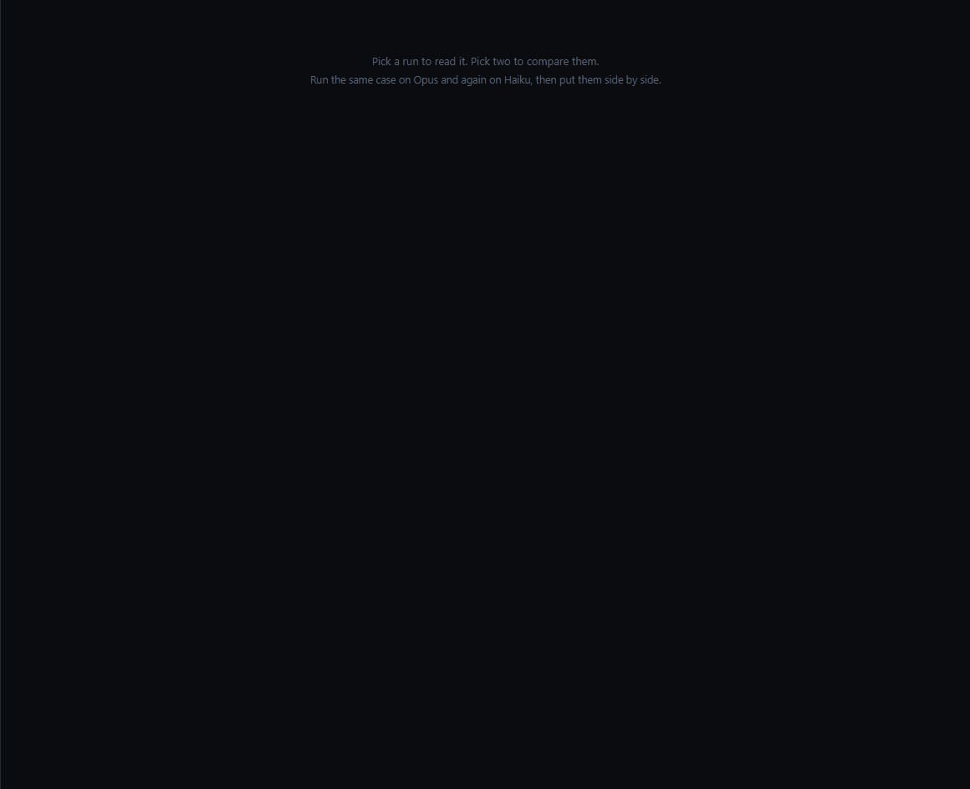
One run opened. Cost, turns, tools and every call it made — this is the record each row of the table above was read from.
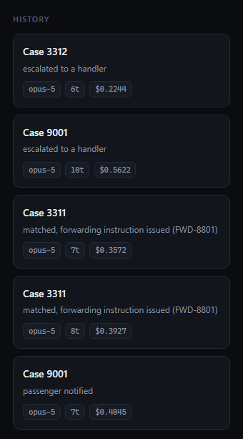
Run history. Every run recorded with its own cost, turns, tools and outcome — which is where every figure on this page came from, and where you should go to check them.

10 What is honestly not there yet
Each of these is a choice with a reason, not an oversight. Knowing the reason is what lets you answer the question rather than absorb it.

It cannot write to WorldTracer
Because that is a commercial negotiation with the industry system's vendor, not an engineering task, and it has not been done. Everything about the design takes this as the starting condition rather than waiting for it: the agent produces the entries a person types, and then checks the record to see whether they did. The result is that the airline gets the judgement, the reasoning and an audit trail that does not exist today, and the vendor has granted nothing. If the access arrives, the handover stage becomes a write and the read-back stays exactly as it is.

There is no governance, audit or data-protection layer
Deliberately out of scope at this stage, by instruction, so that the question of what an agent can usefully do could be answered before the question of how it is controlled. This is the largest gap in the system and it should be said plainly: there is no retention policy, no personal data handling, and no immutable audit store. Run history is a directory of JSON files that anybody with the machine can edit. Access control exists in mock form only — roles are enforced and approvals are signed, but one password is shared by everybody who was invited and the name is then picked from a list, so the signature says who was *selected*, not who was *present*.

There is no evaluation harness
The tests cover mechanism — that the write refuses, that the approval gate holds, that a released bag stops being listed as held. There is nothing that scores the quality of a judgement across a set of cases. Building one needs a set of files with known right answers, which in turn needs either real historical files or a much larger synthetic set. This is the single most valuable thing that could be added next, because it is what would turn 'it did the right thing on three cases' into a number.

There are no clocks and no liability calculations
The Montreal Convention deadlines — twenty-one days to presumed loss, seven days to complain about damage — and the liability limit are described in the project brief and are not built. They belong in code rather than in a model, and they were left out of the demonstration rather than half-built. If somebody asks whether the system knows when a bag becomes legally lost: it does not, yet, and it is a policy engine rather than an AI problem.

The photographs are rendered, not real
Because there is no real photograph set to work from. The system reads real image files and the vision calls are real; the images are generated. Dropping real photographs into the photographs directory replaces them without a code change, which is how this should be tested next. Until somebody does that, nothing is known about how the comparison behaves on a genuine phone snapshot taken in bad light.

One station, one airline, one bag at a time
Muscat arrivals and the on-hand store, SalamAir flights, one file per run. There is no queue, no prioritisation between waiting files, and no notion of a passenger with two bags. Scope was kept small on purpose so that the interesting behaviour was visible rather than buried.

Approve automatically still exists
It is a rehearsal tool and it turns off the main safety rail. It should be removed or put behind an authorisation before anything resembling a pilot. It is in section 11.

11 What happens next
Six decisions. Five of them can be made in any order and revisited. One cannot, and it is first.

THE ONE THAT CANNOT BE FIXED LATER
Start the WorldTracer write-access conversation now, whatever else happens.
Not because the system needs it — it is built not to — but because of the lead time. It is a commercial negotiation with an industry vendor, and the project brief already assumes it will outlast a quarter. Every other item on this list can be started next week and finished inside the same month. This one cannot be compressed by working harder on it later, and if it is not started until the pilot succeeds, the gap between a successful pilot and anything operational is measured in quarters rather than weeks.
The decision needed is not the access itself. It is permission for somebody to open the conversation, and the name of the person who owns it.

The decisions, and who they belong to
The owners below are roles, not names, and the deadlines are marked as unset. Neither has been agreed with anybody, and inventing them here would be the least useful thing this document could do. Filling them in is the first thing to do with this page.
 | Decision | Owner (role) | Deadline
1 | Permission to open the WorldTracer write-access conversation, and who owns it | Commercial / vendor management, with the project sponsor | not set
2 | Whether a shadow-mode pilot on real baggage files is authorised — the agent proposing while humans decide, and the two compared | Ground operations at Muscat, with the project sponsor | not set
3 | Whether the governance, audit and data-protection layer is scoped now or after a pilot decision | Information security and data protection | not set
4 | Who supplies a set of historical no-tag files with known outcomes, so accuracy can be measured rather than asserted | Baggage services, Muscat | not set
5 | Whether real bag photographs can be used, and under what handling rules | Data protection, with baggage services | not set
6 | Removing Approve automatically, or putting it behind an authorisation | Engineering — a small change, but somebody has to say when | not set

What would be built next, if the answer to 2 is yes
- The evaluation harness. A set of files with known outcomes, the agent's proposal scored against what a human actually did, reported as a number that moves when the system changes. Nothing else on this list is worth as much, because everything else is an opinion until this exists.
- The audit store. Every tool call, model call, approval and refusal written somewhere that cannot be edited afterwards. The run history already captures the content; it captures it to editable files.
- Real identity behind the roles. The roster and the permission table exist and are enforced; what is missing is proof that the person selected is the person present. Integrate with the airline's own sign-in so the roles map to groups it already maintains, and the signature on every approval becomes evidence rather than a claim.
- The kill switch. A single action, by a named person, that stops the agent proposing anything. The project brief calls for it and it is not built.
- Degradation to manual. What the desk does when the agent is unavailable, tested rather than assumed.

12 Explaining it to others
This section is written to be used rather than read. The first two pieces are meant to be said aloud more or less as written.

The thirty-second version — say this verbatim

THIRTY SECONDS
“When a bag's tag comes off, the tag number is the only thing our systems can look a bag up by — so the record and the object stop being connected, and somebody has to stand in the store comparing photographs by eye. We built an agent that does the comparing. It reads what the passenger wrote, looks at every bag held at the station, puts the two most likely side by side and says whether they are the same bag and why — and it tells you which scratch it used to decide, so you can check it. Then it works out whether the bag should be flown on or held at the counter, based on where the passenger actually is. It writes nothing. It hands a person the exact entries to type, waits for them to be approved, and afterwards reads the record back and tells you whether the bag actually moved. Two minutes, about 39 cents, and it refuses to guess when the photographs cannot separate two bags.”

The two-minute version — these beats, in this order
- The problem, with one number. Tag comes off, and there are 7 unclaimed bags at Muscat and zero tag numbers to search on. No query answers this.
- What it does, in one line. It reads the file, looks at the photographs, and says which bag is hers and why.
- The moment that lands. There is a second navy case in the store with the same red ribbon. Colour and ribbon alone would have picked the wrong one. It used a scuff mark beside the sticker — an individual wear mark rather than a model feature — and said so.
- The second decision, which is the real point. Two tools were available: fly it on, or hold it here. Nothing chose between them. It read her note — 'I flew on to Salalah this morning, I am at home now' — and forwarded it. On another case it held the bag instead, because Muscat was that passenger's own arrival airport.
- Where it stops. It drafts the message and stops. Show the empty phone. It proposes the instruction and stops again. Two separate signatures, not one.
- Why it stops there and not somewhere else. We have read access to WorldTracer and no write access. So it does not pretend to file anything — it hands a handler the five entries to make.
- The half that makes the rest worth anything. It then reads the record back and reports that the bag has not moved. A person files it, and on the next run the read-back says confirmed. It found out by looking, not by being told.
- The case it refuses. Two identical black cases, no markings. It compares twice, says it cannot tell, and asks the passenger what is packed inside. Then close on that: a system that knows when it cannot tell is what makes the rest of it credible.

Quotations worth memorising
All five are the system's own output, taken from the runs of 3 September 2026. Four of them are refusals, which is deliberate: the refusals are the most persuasive thing this system produces, because anybody can build something confident.

1. The system refusing to write — say this one when somebody asks what it is allowed to do
no write access to WorldTracer. Forwarding ohd-8801 to SLL must be filed by a handler.
the file store's own refusal, raised on every single resolution and shown in the tool output

2. The agent refusing to report success
Status: the bag has not moved. Verify read-back on ohd-8801 shows "not done" — the handler has not yet filed it.
closing summary, case-3311

3. The agent refusing to guess
I won't guess between them. The tie-breaker has to be contents, and only the owner can supply that.
commentary, case-3312, after two comparisons both returned cannot-tell

4. The agent refusing to close a case it had just resolved — the best one, and it was not planned
On this run the agent had matched a bag, prepared a collection hold, and sent a message. Then its own read-back contradicted it, because of a defect since fixed: the bag had already been forwarded to Salalah for another passenger. Nothing told it to check for this.
Problem — do not close this case. The read-back on ohd-8801 contradicts the instruction. It reports state: confirmed, but the file note says "forwarded to SLL, reference FWD-8801." That is a forward to Salalah, not a hold at Muscat. Either the handler filed the wrong entry, or FWD-8801 was already on the file before I got there. […] One thing to fix at the desk: I have already told the passenger the bag is waiting at Muscat. If it turns out to be in Salalah, they need to hear that from us before they walk to the counter — I'd rather correct it than let them find out at the desk.
closing summary, case-9001

5. The agent noticing something nobody asked it to notice
open both cases and check contents against the owner's description — grey wash bag containing a blue asthma inhaler, brown leather sandals size 44, and a rolled prayer mat in the lid pocket. The inhaler is medication, so please treat as time-sensitive.
escalation note, case-3312
Use this one carefully. Nothing in the system mentions medication or urgency; it read a list of belongings and re-prioritised. That is evidence of what the model can notice, not a behaviour the product guarantees. Say 'it noticed', not 'it always notices'.

Two answers to give word-for-word

“What if it gets it wrong?”

SAY THIS
“Then a person catches it, because nothing it decides reaches anybody without somebody approving that exact step. The message to the passenger stops for a signature. The instruction to the handler stops for a second, separate signature — approving one does not approve the other. And the handler's first step is always to check the bag against the photograph physically, before anything moves. What we have removed is the hour of comparing, not the judgement. And when it can't tell, it says so and escalates — we can show you that case.”

“Is it just making the reasoning up to sound convincing?”

SAY THIS
“It might be, and that is exactly why both photographs are on the screen underneath the verdict. It said the deciding feature was a pale scuff to the right of the sticker at the same height in both images — so look at the two pictures and check. If it isn't there, the reasoning is wrong and you can see that it's wrong in two seconds. That is the difference between a system that gives you a score and one that gives you a reason: a reason can be falsified by looking. Also worth knowing — the verdict can only be one of three words, and one of them is 'cannot tell'.”

Three things not to say
- Do not say it saves any particular amount of time. No baseline has been measured. Say 'about two minutes per case, and nobody has yet measured what it takes today' — which is a better answer anyway, because it invites them to find out.
- Do not say it is accurate to any percentage. Nothing has been scored. Say that it reaches the intended answer on the demonstration cases and that building the measurement is the next thing on the list.
- Do not describe section 5 as one continuous run. It is three runs, and each stage names its own.

13 Appendices

A. Glossary
AHL | Advice of Hold — the baggage file raised when a passenger reports a bag missing. `ahl-3311` is one.
OHD | On-Hand — a file for an unclaimed bag found at a station. `ohd-8801` is one. Resolving a case means matching an AHL to an OHD.
No-tag match | Matching an AHL to an OHD when the bag tag has detached, so there is no identifier to join them on. The problem this system exists for.
WorldTracer | The industry system where baggage files authoritatively live. This system reads a WorldTracer-shaped export and cannot write to WorldTracer at all.
Phase A | Read access to the systems of record and no write access. The agent produces the entries a person types, a person types them, and the agent reads the record back to check. The whole system is designed for this condition rather than waiting for it to end.
`read` tool | A tool that runs the moment the agent asks for it. There are 7.
`act` tool | A tool that halts the run for a person's approval because the outside world would notice it. There are 4: message the passenger, ask the passenger, and the two handover instructions.
awaiting_approval | A run stopped for somebody at the desk to approve one specific tool call.
awaiting_reply | A run stopped for a passenger to answer. Nobody at the desk can clear it, which is what makes it different from an approval.
cannot_tell | One of the three verdicts the comparison call may return. A normal answer, not a failure.
Handover instruction | The numbered list of entries a handler makes, each with what it should return. Generated by code, not written by the model.
Read-back | Re-reading the baggage record after an instruction was issued, to report what it now says rather than what was asked for. Pure code.
Effort | How much reasoning a model call is allowed. Comparison runs highest, perception high, drafting medium.
MCT / SLL / OV | Muscat, Salalah, and SalamAir's flight prefix.

B. Where to go deeper
Document | What it is for | Read it when
products/abr/docs/BRIEF.md | The project brief: pilot scope, the principles the design follows, the legal clocks and liability seeds that are planned but not built, and the systems of record | You need the reasoning behind a design decision, or the intended scope of a real pilot
products/abr/docs/DEMO.md | How to run the demonstration in front of people: the order, the lines that land, what not to do | You are presenting it
docs/OWNER_MANUAL.docx | The system owner's manual, covering both products — what they are, how they work, how to run them | Somebody needs to understand the platform rather than this product
docs/DEMO_BRIEFING.docx | Expected questions and prepared answers for a demonstration | You are about to be asked hard questions
README.md | How to install and run either product from a clean machine | You want it running on your own machine
tools/build_abr_walkthrough.py | The generator for this document. Every figure in it is a named constant at the top, with the date it was measured | A number in here looks wrong, or the product has changed
products/abr/apps/console/tools/capture-shots.mjs | The script that captured every screenshot in this document by driving the running product | You want to reproduce the screenshots, or check that a screen still looks like its picture

C. Rebuilding this document
The document is generated, not maintained by hand, so that the figures in it come from one place and can be corrected in one place.
Regenerate the document | make abr-walkthrough
Recapture the screenshots  (needs the product running) | make abr-shots
Start the product | scripts\demo-abr.bat
Recapture one part only | `ONLY=a node tools/capture-shots.mjs` — a, b or c

If a screenshot is missing when the document is built, the build says so on the console and leaves a marked gap on the page rather than substituting a picture from another run. A gap in this document means that step did not happen on the run it was built from.

